Architecting a Lightweight Cloud-Based Inventory and Financial Management System: A Mixed-Methods Evaluation of Decision-Making Efficiency in Philippine SMEs

A Capstone Project Presented to the

Faculty of the

College of Information Technology and Engineering

Southwestern University -PHINMA

In Partial Fulfillment

of the Requirements for the Degree

BACHELOR OF SCIENCE IN INFORMATION TECHNOLOGY

By

Evon Christian Pahugot Vergara
Justin Comendador
Xymmer James Nadera

2026

TABLE OF CONTENTS

TABLE OF CONTENTS 2
LIST OF FIGURES 4
LIST OF TABLES 5
CHAPTER 1 6
INTRODUCTION 6
Background of the Study 6
Statement of the Problem 8
Objectives of the Study 10
Scope and Limitations 12
Limitations of the Study 15
Significance of the Study 16
Definition of Terms 18
CHAPTER 2 23
REVIEW OF RELATED LITERATURE 23
Challenges and Operational Bottlenecks Faced by Small and Medium-Sized Enterprises 24
System Frameworks and Information Security Measures of the Proposed System 25
Acceptability Level of the Proposed Cloud-Based Inventory and Financial Management System 27
Summary of the Review of Related Literature 28
CHAPTER 3 29
RESEARCH AND SYSTEM DEVELOPMENT METHODOLOGY 29
Research Framework and Design 29
Sampling and Techniques 31
Data Gathering Tools and Techniques 34
Procedures for Data Collection 37
Project Timeline and Milestones 39
Project Estimated Cost 41
Software Development Methodology 42
Conceptual Framework 44
Software Development Tools 45
Project Features 48
Use-Case Diagram 52
Context Flow Diagram 54
Data Flow Diagram 55
Mock-ups and Prototype 56
Data Analysis Tools and Techniques 72
CHAPTER 4 75
RESULTS AND DISCUSSIONS 75
Response Rate 75
Demographics 76
Findings for Research Question 1 77
Baseline workflow conditions from the pre-survey 77
Perceived effects of the current workflow on efficiency 81
Qualitative themes from the interview transcripts 82
Integrated discussion of the quantitative and qualitative findings 88
Summary of Findings 90
References 91

LIST OF FIGURES

Figure No. | Figure Title | Page
3.1 | Agile Development Cycle Used in the Study | 40
3.2 | Conceptual Framework of the Kodigo System | 42
3.3 | UML Use-Case Diagram of the Kodigo System | 49
3.4 | Context Flow Diagram of the Kodigo System | 50
3.5 | Data Flow Diagram (Level 1) of the Kodigo System | 51
3.6 | Admin Onboarding Page | 53
3.7 | Login Page | 54
3.8 | General Settings Page | 55
3.9 | User Management Page | 56
3.10 | Invite User Modal | 56
3.11 | Notification Preferences Page | 57
3.12 | Security Settings Page | 58
3.13 | Dashboard Page | 59
3.14 | Inventory List Page | 60
3.15 | Add Product Page | 60
3.16 | Suppliers Page | 61
3.17 | Add Supplier Page | 62
3.18 | Restocking Page | 63
3.19 | Point-of-Sale Page | 64
3.20 | Analytics Page | 65
3.21 | Product Rankings Page | 66
3.22 | Mean Formula | 68
3.23 | Standard Deviation Formula | 68
4.1 | Demographic and Operational Profile of Pre-Survey Respondents | 72
4.2 | Common Causes of Reconciliation Issues Reported in the Pre-Survey | 74
4.3 | Decisions Most Frequently Delayed by Inventory or Reconciliation Issues | 75
4.4 | Mean Scores of the RQ1-Related Perception Items | 77
4.5 | Thematic Map of the Qualitative Findings for Research Question 1 | 79

LIST OF TABLES

Table No. | Table Title | Page
3.1 | Sample Distribution of Participants | 31
3.2 | Project Timeline and Milestones | 38
3.3 | Estimated Project Cost | 39
3.4 | Software Development Tools | 43
3.5 | Project Features | 45
4.1 | Key Baseline Indicators Related to Research Question 1 | 74
4.2 | Mean Ratings on Current Workflow Conditions and Operational Effects | 76
4.3 | Interview Participant Contexts Included in the Thematic Analysis | 78
4.4 | Themes, Sub-Themes, and Illustrative Quotes from the Interview Data | 80
4.5 | Integrated Summary of the Quantitative and Qualitative Findings for Research Question 1 | 83

CHAPTER 1

INTRODUCTION
In the Philippine market, many local businesses still rely on localized Point of Sale (POS) systems that do not communicate effectively with a central database, leading to "data lag" and operational blind spots. This research project focuses on the development and implementation of a cloud-based management framework designed to bridge the gap between these disparate inventory systems and financial reporting protocols. By leveraging real-time data synchronization, the study aims to provide enterprise owners, particularly within the Cebu City market, with a unified platform that ensures consistency, reduces manual errors, and provides a scalable technological roadmap for operational sustainability.

Background of the Study
The global business landscape has undergone a significant paradigm shift, evolving from manual, paper-based ledger systems to localized digital tools, and effectively toward integrated cloud ecosystems. Internationally, the adoption of cloud technology has become a cornerstone for Small and Medium Enterprises (SMEs) aiming to scale, as these platforms allow for real-time data synchronization across disparate geographical locations. However, while global markets have largely transitioned to these automated environments, a substantial portion of the SME sector in developing regions remains tethered to fragmented legacy systems. According to Nevalga (2022), while Philippine MSMEs recognize the relative advantage of cloud adoption, they often face significant barriers related to implementation costs and a lack of government-supported infrastructure.
In the Philippine market, this digital divide is not merely a lack of hardware but a structural issue regarding connectivity. The current operational standard for many local businesses relies on localized Point of Sale (POS) terminals that function in isolation. Unicommerce (2026) identifies this reliance on manual documentation and inconsistent tracking as a primary threat to local brands, creating data silos where inventory movement at the branch level does not reflect in the financial master data. Consequently, business owners are forced to depend on delayed manual reconciliation, a process that is historically error-prone and time-consuming. These operational blind spots inevitably lead to data lag, leaving management without a real-time view of total assets and complicating critical tasks such as tax compliance and profit auditing.
To address these inefficiencies, this research proposes the development of a Cloud-Based Inventory and Financial Management System. This integrated approach is supported by recent findings in the field; for instance, Ayochok and Perez (2024) highlighted that enhancing inventory systems is critical for resolving inefficiencies caused by manual procedures in local institutions. Furthermore, transitioning to automated platforms significantly improves decision quality. As noted by CloudCFO (2025), cloud automation reduces overhead costs and provides management with real-time visibility into cash flow, which is essential for long-term sustainability. Additionally, comparative studies establish that system-driven inventory tools significantly outperform manual tracking in terms of speed and error reduction (Conde et al., 2026).
Ultimately, the shift toward a Cloud-Based Inventory and Financial Management System is no longer a luxury but a necessity for competitive survival. This study seeks to validate a technological framework specifically tailored to the resource constraints of Cebu City’s SMEs. By bridging the gap between physical inventory and digital financial records, this project aims to establish a "Single Source of Truth" that empowers local business owners to move from reactive troubleshooting to proactive strategic planning.

Statement of the Problem
Multi-branch SMEs frequently encounter operational inefficiencies due to a reliance on manual inventory tracking and financial reconciliation. These disjointed processes result in inaccurate stock data, delayed financial reporting, and revenue inconsistencies. To address these critical gaps, this research aims to design and implement a Cloud-Based Inventory and Financial Management System that automates data synchronization and enhances decision-making. Specifically, this study seeks to answer the following questions:
- What are the key challenges and operational bottlenecks faced by SMEs in manual inventory tracking and error-prone financial reconciliation processes, and how do these challenges impact their overall efficiency in terms of:
a. Inaccurate inventory tracking
b. Slow decision-making
c. High operational cost
d. Data inconsistency
- What system framework and information security measures are most appropriate for the development of the proposed Cloud-Based Inventory and Financial Management System, as evaluated by qualified technical validators in terms of:
a. System Architecture and Framework Design
b. Data Security and Access Control
c. Role-Based Access and User Privilege Management
d. Data Integrity and Transmission Security

- What is the level of acceptability of the developed Cloud-Based Inventory and Financial Management System among intended users and technical evaluators in terms of:
a. Cost-effectiveness
b. System reliability
c. Operational efficiency
d. Security

Objectives of the Study
The primary objective of this study is to design, develop, and evaluate a cloud-based inventory and financial management framework tailored for small and medium enterprises. The study aimed to address existing operational challenges in inventory tracking and financial reporting while ensuring that the proposed solution is acceptable to its intended users. Specifically, the study seeks to achieve the following objectives:
- Identify the key challenges and operational bottlenecks experienced by SMEs on manual inventory tracking and error-prone financial reconciliation processes, and analyze how these challenges impact their overall efficiency in terms of :
  - Inaccurate inventory tracking
  - Slow decision-making
  - High operational cost
  - Data inconsistency
- Determine the most appropriate system framework and information security measures for the proposed Cloud-Based Inventory and Financial Management System, as validated by qualified technical evaluators in terms of:
  - System architecture and framework design
  - Data security and access control
  - Role-based access and user privilege management
  - Data integrity and transmission security

- Evaluate the level of acceptability of the developed system among intended users in terms of:
  - Cost-effectiveness
  - System reliability
  - Operational efficiency
  - Security

Scope and Limitations
The digital transformation of Small and Medium Enterprises (SMEs) in the Philippines is often hindered by fragmented systems that isolate critical business data. To address this, the primary focus of this research is the design, development, and architectural validation of a Cloud-Based Inventory and Financial Management System specifically tailored for multi-branch business structures. Although the initial testing and framework design are based on the operational needs of SMEs in Cebu City, the findings and the developed roadmap may provide useful guidance for SMEs in comparable settings beyond the city.. To clearly define the boundaries of the investigation and the technical deliverables, the scope is divided into two distinct categories: the Scope of the Study, which outlines the research parameters and target users, and the Scope of the System, which details the specific technical features and architectural specifications to be developed.

Scope of the Study
This study focuses on the design, implementation, and evaluation of a Cloud-Based Inventory and Financial Management System to address synchronization challenges between physical inventory and financial records in SMEs. In the implemented role structure, the Super Admin is limited to generating invite codes for Admin account creation, business owners function as Admin users, and operational staff use the system according to assigned permissions, including Cashier and Inventory roles.
a. Business owners, who function as Admin users and require store-level and multi-store visibility for strategic decision-making and operational oversight
b. Operational staff, particularly Cashiers and Inventory personnel, who use the system according to assigned permissions for sales processing, product and stock maintenance, replenishment, and related day-to-day store tasks

The study specifically emphasizes the synchronization of point-of-sale (POS) data with a centralized inventory database to establish a “single source of truth” across all business branches. It covers system development, framework validation, security evaluation, and user acceptability assessment. The implemented application includes descriptive analytics, product rankings, and sales-velocity views, but does not include AI-driven forecasting or predictive machine learning.

Scope of the System
The technical development of the Cloud-Based Inventory and Financial Management System includes the following core functionalities and architectural components:
Core Functionality: The system combines online-first inventory and POS synchronization with base-unit stock control, configured selling options, supplier and purchase-order workflows, and automated calculations for sales and inventory reporting.
Technical Stack: The implemented application uses React with TypeScript and Vite for the frontend, Tailwind CSS and Zustand for interface/state management, and Supabase PostgreSQL, Auth, Row Level Security, Storage, and Edge Functions for protected backend services. IndexedDB supports bounded browser caching and mutation queueing; jsPDF and write-excel-file support receipt and report outputs, with Vercel SPA routing configuration for deployment.
Information Security: The framework includes Supabase authentication, invite-based onboarding, role-based access control, TOTP multi-factor authentication with AAL2 assurance when enrolled, Row Level Security, server-side validation, and protected functions. These controls separate the invite-governance Super Admin, operational Admin, Cashier, and Inventory roles within assigned store scope.

Limitations of the Study
Specific Focus: The study will only explore the implementation of the cloud-based framework for inventory and financial synchronization ; it does not cover external factors like supply chain logistics, fleet management, or raw material procurement.
Implementation Depth: The research evaluates the developed prototype/application within the selected SME context and supported store scope rather than claiming a full-scale national deployment.
Security Limitations: While the system addresses data protection, the study does not cover full-scale cybersecurity solutions or the specifics of advanced international security certifications.

Limitations of the System
The most significant constraint imposed on the system architecture is the intentional exclusion of Artificial Intelligence (AI) and Machine Learning (ML) integrations. While AI forecasting is prevalent in enterprise solutions, it has been excluded here to keep the system lightweight and maintainable for SMEs without dedicated IT personnel. The application provides descriptive analytics, rankings, sales velocity, and financial values derived from recorded transactions for internal decision support; it is not certified accounting software and does not provide automatic tax filing with the Bureau of Internal Revenue (BIR). The application is online-first and uses bounded browser caching plus queued POS or generic mutations when connectivity is interrupted, while comprehensive offline reporting and automatic conflict-resolution mechanisms remain beyond this iteration.

Significance of the Study
The development of a cloud-based management framework for multi-branch SMEs holds substantial value for various stakeholders by addressing the critical gap between physical operations and digital financial records. Beyond solving immediate operational issues, this research serves as a strategic model for digital transformation that can be adapted by SMEs in other regions of the Philippines and throughout Southeast Asia to improve global competitiveness. The significance of this study is detailed below:
Business Owners and Investors: This study provides a technological roadmap to achieve a single source of truth across multiple business locations. By implementing this system, owners gain immediate, real-time visibility into the health of their business, eliminating the blind spots caused by delayed reports. This transparency allows for more accurate profit auditing, minimizes financial leakage due to unrecorded transactions, and provides the data-backed confidence required for informed strategic scaling and investment in new branches.
Branch Managers and Operations Staff: The framework significantly reduces the administrative burden associated with manual inventory reconciliation. By automating the synchronization of data between the Point of Sale (POS) and the central database, the system minimizes human error in financial logging. This operational shift ensures that staff can redirect their energy away from tedious troubleshooting of data discrepancies and toward value-adding activities, such as improving customer service and optimizing daily store operations.
The Local SME Sector in the Philippines: As many local businesses still rely on fragmented legacy systems, this research serves as a practical model for digital transformation within the Philippine context. It demonstrates how accessible cloud infrastructure can be leveraged to modernize traditional business models, allowing SMEs to compete with larger enterprises. By adopting such cost-effective, high-efficiency technologies, local sectors can improve their resilience, operational standards, and overall contribution to the digital economy.
Information Technology Students and Practitioners: This study contributes significantly to the academic growth of IT students by serving as a reference for applying theoretical concepts to real-world problems. It provides a concrete example of how to architect a complex system using the React technology stack and cloud backend services. Furthermore, it offers students a case study on the importance of state management and real-time data synchronization, bridging the gap between classroom coding exercises and industry-standard software development.
Researchers: Future researchers can utilize this study as a foundational reference for investigations related to cloud adoption rates, SME digitalization, and inventory management systems. The data and architectural framework presented here can serve as a baseline for further studies that may explore advanced features, such as the integration of Artificial Intelligence for demand forecasting or the application of blockchain for immutable financial auditing.
Software Developers: For developers within the industry, this project highlights specific technical challenges and solutions regarding the integration of frontend interfaces with real-time cloud databases. It offers valuable insights into designing scalable architectures that handle multi-branch data concurrency. The documentation of the development process, specifically regarding data consistency and user authentication, serves as a technical guide for building similar SaaS (Software as a Service) platforms tailored for the retail industry.

Definition of Terms
To help you understand the technical terms used in this study, the following definitions are organized alphabetically for your reference.

API (Application Programming Interface) | A set of rules and protocols that allow the frontend of the management system to communicate with the cloud-based backend and database.
Audit Trail | A chronological record of user and system actions, including sales, inventory adjustments, returns, and other protected changes, used for accountability and review.
Backend-as-a-Service (BaaS) | A cloud service model that provides managed backend capabilities such as authentication, database access, storage, and server-side functions; Kodigo uses Supabase for these services.
Centralized Database | A PostgreSQL database hosted through Supabase that stores shared business records subject to store membership and Row Level Security policies.
Cloud-Based Management Framework | The connected application architecture used by Kodigo to centralize inventory, POS, supplier, reporting, and security workflows through a browser-based system.
CRUD (Create, Read, Update, Delete) | The basic persistent-record operations used for authorized product, supplier, store, user, and reporting data management.
Dashboard | A summary view of selected-store or assigned-store metrics such as today’s net revenue, transactions, average order value, gross profit, stock alerts, trends, and recent transactions.
Data Discrepancy | A lack of agreement or balance between physical inventory counts and the digital financial reports generated by the system.
Data Integrity | The maintenance of, and the assurance of the accuracy and consistency of, data over its entire life-cycle within the cloud framework.
Financial Reporting Accuracy | The degree to which reported values agree with recorded transactions and inventory movements; in this study it is a quality to evaluate, not a claim of accounting certification.
Inventory Synchronization | The persistence and refresh of transaction and base-unit stock records across authorized connected clients; Kodigo is online-first and supplements this with bounded offline queueing.
Multi-Branch SME | A small to medium enterprise that operates through several physical locations or outlets managed under a single organizational structure.
POS (Point of Sale) System | The sales interface used to search products, configure quantities or selling options, accept supported payments, apply discounts, and generate receipt records.
React | A declarative, efficient, and flexible JavaScript library used for building the user interface of the management framework.
Real-Time Data Processing | Processing and displaying connected requests promptly after server validation; Kodigo does not claim full offline real-time consistency or automatic conflict resolution.
Scalability | The capability of the management framework to handle a growing amount of work or its potential to be enlarged to accommodate more branches.
Single Source of Truth (SSOT) | A design principle in which canonical business records, particularly base-unit stock and transaction history, are maintained in one authoritative database rather than edited independently by branches.
State Management | The handling of application data and UI state needed to display selected-store records, cart contents, authentication status, and queued operations consistently.
Supabase | The managed backend platform used by Kodigo for PostgreSQL, authentication, Row Level Security, storage, Edge Functions, and database access.
PostgreSQL | The relational database engine that stores Kodigo profiles, stores, products, suppliers, purchase orders, sales, receipts, history, and reporting records.
Row Level Security (RLS) | Database policies that restrict records and protected operations according to the authenticated user, role, and assigned store.
Multi-Factor Authentication (MFA) | An additional authentication factor; Kodigo supports TOTP verification and uses AAL2 assurance for protected operations when a factor is enrolled.
Base Unit | The canonical unit in which product quantity on hand, stock movements, and server-side deductions are maintained.
Restocking Unit | A supplier package format such as a pack, box, case, or tray that is converted to base units using a configured factor during receiving.
Selling Option | A configured way to sell shared base stock, such as a piece, kilo, sack, or custom package, with its own quantity multiplier and price rule.
Quantity on Hand (QOH) | The current available base-unit quantity for a product in a selected store.
Sales Velocity | The descriptive rate of completed net base units sold over a selected 7-, 30-, or 90-day period, used with QOH to classify replenishment urgency.
Historical Snapshot | A transaction-time copy of values such as selling price, purchase cost, product option, tax, discount, or receipt details so later master-data edits do not rewrite history.
Offline Queueing | The bounded capability to cache product data and queue supported POS or generic mutations in the browser for replay when connectivity returns; it is not comprehensive offline operation.

CHAPTER 2

REVIEW OF RELATED LITERATURE
Recent studies emphasize the increasing role of digital technologies in transforming the operational practices of Small and Medium Enterprises (SMEs), particularly in inventory and financial management. Cloud computing has emerged as a significant technological innovation that allows SMEs to improve operational efficiency and enhance decision-making processes. Cloud-based financial systems allow organizations to access updated financial information from any location through internet-based platforms, enabling managers to monitor financial performance continuously and make faster and more accurate financial decisions (Nguyen & Hoang, 2025). Similarly, cloud-based accounting information systems improve financial reporting by enabling managers to observe transactions and operational activities in real time, allowing organizations to identify inconsistencies early and maintain more reliable financial records (Vo Van et al., 2026). Cloud accounting systems improve organizational coordination by allowing multiple departments to access shared financial data while automating financial transactions, which enhances the efficiency of financial management processes within SMEs (Septiawan et al., 2025). Cloud-based management information systems enhance organizational decision-making by providing centralized access to operational data and real-time analytical tools that allow managers to analyze business performance more effectively (Ashrafuzzaman, 2024). Real-time inventory monitoring systems allow businesses to track stock levels continuously, which reduces discrepancies and improves inventory control within SMEs (Daniel & Archie, 2024). Integrating predictive analytics with real-time inventory monitoring allows organizations to anticipate demand patterns and make better decisions regarding stock replenishment and inventory planning (Nasir & Martha, 2024).
Overall, the literature indicates that cloud-based inventory and financial management systems provide SMEs with centralized data management, automated financial processes, and real-time operational monitoring, which reduces inefficiencies associated with manual systems and enables managers to make faster and more informed decisions.

Challenges and Operational Bottlenecks Faced by Small and Medium-Sized Enterprises
Small and medium enterprises continue to encounter operational bottlenecks when inventory records and financial data are maintained through manual, disconnected processes. One recurring problem is inventory record inaccuracy. Shabani et al. (2021) explained that inventory record inaccuracy occurs when the quantity recorded in the inventory system does not match the quantity physically available. In practical SME operations, this mismatch can result from delayed stock encoding, manual stock counts, and branch-level recording inconsistencies, which contribute to stock discrepancies, stockout risks, and unreliable inventory information for day-to-day decisions. Manual financial reconciliation also creates reporting delays and workflow inefficiencies. Kosadi et al. (2021) found that when data from multiple transaction platforms are manually integrated into internal reports, the process tends to produce duplicated records, longer reporting cycles, and a greater chance of error. For SMEs that still reconcile sales, inventory movements, and financial records through spreadsheets or separate branch files, reconciliation becomes dependent on repeated checking, matching, and correction before reports can be finalized. This slows the release of financial information needed for operational and managerial decisions. Another bottleneck is the lack of real-time visibility across inventory and financial records. When stock updates and transaction records are encoded manually and reconciled only after transactions have accumulated, business owners and managers are left with delayed and sometimes inconsistent operational data. As noted by Kosadi et al. (2021), records duplication and non-automated reconciliation processes prolong processing time, while Shabani et al. (2021) showed that inaccurate inventory records can distort inventory and sales management performance. In multi-branch SME settings, these conditions can intensify reporting inefficiencies, create uncertainty in stock monitoring, and increase the amount of time spent resolving discrepancies rather than supporting routine operations.

System Frameworks and Information Security Measures of the Proposed System
The reviewed literature indicates that an effective cloud-based inventory and financial management system for SMEs should be grounded in a centralized and scalable system framework. Luo (2024) explained that, within a cloud computing environment, the construction mode of SME accounting informatization should be evaluated using factors such as cost, safety, stability, flexibility, expansibility, technical ability, and human resources. Applied to the proposed system, this supports a framework in which inventory, sales, and financial records are stored in a shared cloud environment so that branch-level transactions can be synchronized into a unified database structure. A centralized cloud framework is also relevant because the proposed system combines operational and financial data that must remain consistent across users and locations. Luo (2024) further noted that cloud computing-based models are evaluated against traditional approaches in terms of flexibility and scalability, which are important for systems that need to support multiple users, branch transactions, and continuous updates. This supports the design of a cloud-based platform in which inventory tracking, transaction recording, and financial reporting are integrated within one system environment rather than maintained in isolated records. Information security measures are equally critical in the design of the proposed system. Nagahawatta et al. (2024) identified cloud security standards, data privacy concerns, data security concerns, skilled personnel, technology readiness, legal compliance, and trust in cloud service providers as security-related factors that shape SME cloud computing decisions. These factors suggest that the proposed system should not only store data in the cloud but also apply security controls that protect confidentiality, integrity, and authorized access to financial and inventory records. SMEs also face cybersecurity vulnerabilities due to limited protective measures, constrained financial resources, and inadequate cybersecurity expertise, which makes the inclusion of practical and cost-conscious security controls important in cloud-based system design (Manzoor et al., 2024). Literature on cloud security also emphasizes the role of authentication and access control in securing cloud-based systems. Mohammad (2022) stated that access control protects confidentiality by ensuring that data are disclosed only to authorized users and protects integrity by limiting alteration of resources to legitimate users. In the context of the proposed system, this supports the use of user authentication mechanisms and role-based access control so that business owners, managers, and staff members are granted only the functions and records appropriate to their roles. For cloud-native and scalable systems, secure communication and authorization mechanisms must also be considered in the framework design. Rahaman et al. (2023) reported that role-based access control was the most efficient access control mechanism in the reviewed cloud-native studies and noted that secure communication should implement Mutual Transport Layer Security (mTLS) or JSON Web Token (JWT). These findings support the inclusion of authenticated user sessions, protected API communication, and role-based permissions in the proposed cloud-based inventory and financial management system to strengthen secure access and data protection.

Acceptability Level of the Proposed Cloud-Based Inventory and Financial Management System
Research examining technology adoption among small and medium enterprises highlights several factors that influence the acceptability of cloud-based systems. Relative advantage, compatibility, complexity, organizational readiness, and top management support significantly influence SMEs’ intentions to adopt cloud accounting systems (Rashid et al., 2024). Organizational capabilities also play an important role in technology adoption. Digital culture, top management support, human resource capability, and adoption costs are among the most important predictors of digital technology adoption in SMEs (Faiz et al., 2024). Operational efficiency improvements are also important determinants of system acceptance. Data-driven financial management systems improve organizational decision-making by providing real-time financial insights that support budgeting, forecasting, and strategic planning (Ige et al., 2024). System reliability is another important factor influencing technology acceptance among SMEs. Cloud-based accounting systems enhance organizational performance by enabling continuous system availability, improved data integrity, and real-time access to financial information (Vo Van et al., 2026). Security considerations also influence adoption decisions. Security and privacy concerns remain critical factors influencing SME adoption of cloud computing technologies (Nagahawatta et al., 2024).

Summary of the Review of Related Literature
The literature reviewed in this chapter shows that manual inventory tracking and financial reconciliation create persistent operational bottlenecks for SMEs, particularly in the areas of inventory discrepancies, delayed reconciliation, limited real-time visibility, and inefficient reporting workflows. These issues affect the quality and timeliness of information available to business owners and managers, making routine and strategic decisions more difficult. The reviewed works also show that a cloud-based system framework is appropriate for integrating inventory, sales, and financial records within a centralized platform. A well-designed cloud framework supports synchronized data processing, shared access across authorized users, and a structure that can adapt to the operational requirements of growing SMEs. The literature further highlights that system design must be supported by appropriate security measures. Authentication controls, role-based access, secure data transmission, and broader data protection practices are essential in protecting sensitive operational and financial information stored in the cloud. Taken together, the reviewed literature supports the need for a cloud-based inventory and financial management system that can reduce the inefficiencies of manual processes while providing SMEs with a more integrated, secure, and decision-oriented platform.

CHAPTER 3

RESEARCH AND SYSTEM DEVELOPMENT METHODOLOGY
This chapter presents the methodology used to design, develop, and evaluate the proposed Cloud-Based Inventory and Financial Management System for small and medium enterprises (SMEs). It describes the study's method and research design, sampling approach, data gathering tools and techniques, procedures for data collection, project timeline, estimated cost, software development methodology, conceptual framework, software development tools, use-case diagram, and data analysis tools and techniques. The methodological choices were aligned with the study's three research questions so that existing operational problems could be examined, translated into system requirements, and evaluated through a functional prototype.

Research Framework and Design
This study adopts a mixed-method approach arranged in an exploratory sequential manner. The qualitative component is used first to understand the operational realities of SMEs that still rely on manual or partially digitized inventory tracking and financial reconciliation. Insights from this phase inform the system requirements, workflow logic, and information security considerations of the proposed cloud-based system. The quantitative component is then used to describe baseline operational conditions and to assess the post-implementation acceptability of the prototype. Mixed-method inquiry is appropriate for applied information systems research because it enables researchers to combine narrative explanations of user experience with numerical indicators of operational conditions and system evaluation (Creswell & Plano Clark, 2017; Fetters et al., 2013; Morgan, 2013).
Research Question 1 is addressed through a mixed-method strand. Qualitative interview data are used to identify operational bottlenecks, while quantitative baseline questionnaire data are used to describe the frequency and extent of current problems such as inventory discrepancies, delayed reconciliation, and data inconsistency. Research Question 2 is addressed through a quantitative strand. Structured technical validation ratings are used to determine the appropriateness of the proposed system framework and information security measures for the cloud-based solution. Research Question 3 is addressed through a quantitative strand. Survey responses gathered after prototype interaction are used to determine the level of acceptability of the system in terms of cost-effectiveness, system reliability, operational efficiency, and security.
Three complementary research designs support the method adopted in this study. First, a descriptive design is used for Research Question 1. This design is appropriate because the study must document current inventory and financial management practices and describe the operational consequences of manual or fragmented processes in real SME settings. Descriptive inquiry is suitable when the goal is to present the characteristics of an existing condition as experienced by participants and observed in practice. Second, a developmental-evaluative design is used for Research Question 2. This design is appropriate for information technology studies that move from problem diagnosis to system planning, prototyping, refinement, and quantitative technical validation. In the present study, the developmental-evaluative design translates operational needs into system modules, user roles, data flows, and security safeguards, then uses structured validation ratings to determine whether the proposed framework and information security measures are appropriate for the intended SME environment. Prior research also indicates that meaningful user involvement contributes to higher system relevance and implementation success (Bano et al., 2015). Third, an evaluative design is used for Research Question 3. After the prototype is developed and exposed to intended users, an evaluative design makes it possible to assess whether the system is acceptable and useful in the target setting. This is consistent with information systems acceptance literature, which emphasizes the importance of user perceptions, system characteristics, and performance benefits in determining likely adoption and continued use
Overall, the selected framework is appropriate because it connects diagnosis, development, and evaluation within one coherent study. The design allows the researchers to begin with the actual problems faced by SMEs, convert those problems into technical requirements, and then determine whether the resulting system is acceptable for practical use.

Sampling and Techniques
This study uses non-probability purposive sampling, specifically criterion-based purposive sampling with elements of maximum variation sampling. The sampling technique is appropriate because the study requires participants who have direct and relevant experience in inventory monitoring, sales recording, financial reconciliation, and system use within SME operations, as well as qualified technical evaluators capable of assessing the proposed system framework and information security measures. Criterion-based purposive sampling ensures that all participants possess the characteristics necessary to answer the research questions, while maximum variation strengthens the study by including participants from the partner enterprise and from similar SMEs with comparable operational conditions (Palinkas et al., 2015). The main participant criteria are as follows: (1) for the interview phase, the participant is a business owner or manager of the partner SME or of a comparable SME; (2) for the survey phase, the participant is a business owner, manager, or operations staff member involved in daily sales, inventory-related work, or financial reconciliation; and (3) for the technical validation phase, the participant is a qualified IT instructor, system developer, database specialist, or information systems practitioner capable of evaluating the appropriateness of the proposed system framework and security measures. Including participants from comparable SMEs broadens the empirical base of the study and reduces the risk of drawing conclusions from a single organizational context only. A case-oriented approach supported by comparable settings is appropriate when the study seeks to understand patterns across real-world environments rather than isolate variables in a laboratory setting (Crowe et al., 2011). The adequacy of the qualitative interview sample is supported by the information power of the selected respondents because interview participants are deliberately chosen for their managerial and decision-making relevance (Malterud et al., 2016). For the quantitative components, all identified operational respondents will be included in the baseline and acceptability surveys, while multiple qualified technical evaluators will be engaged to provide structured validation ratings for Research Question 2. Table 3.1 presents the distribution of participants.

Participant Category | Number of Participants
Client Business Owner/Manager | 1
Client Operations Staff | 5
Owners/Managers from Similar SMEs | 4
Operations Staff from Similar SMEs | 8
Technical Validators/IT Experts | 3
Total Participants | 21
Table 3.1. Sample Distribution of Participants
The distribution reflects the study’s intent to capture both managerial and operational perspectives through different instruments. Owners and managers will serve as the qualitative interview informants, contributing strategic, supervisory, and decision-making perspectives on inventory monitoring, reconciliation practices, and business inefficiencies. Owners/managers and operations staff will participate in the quantitative surveys to provide baseline and post-implementation data regarding operational practices and system acceptability. The technical validators/IT experts will separately provide quantitative ratings on whether the proposed architecture and security controls are appropriate for SME use. This combination supports the qualitative diagnosis of operational problems, the quantitative evaluation of the system framework and information security measures, and the quantitative evaluation of acceptability.

Data Gathering Tools and Techniques
Data gathering in this study is organized according to the method assigned to each research question. Separate instruments were prepared for qualitative inquiry, baseline quantitative profiling, and post-implementation system evaluation. To maintain methodological clarity, the tools refer to the instruments used to collect information, while the techniques refer to the procedures through which those instruments are administered.

Data Gathering Tools
Semi-Structured Interview Guide. This instrument will be used with business owners/managers only to obtain detailed descriptions of current workflows, recurring stock discrepancies, reconciliation delays, cost implications, and decision-making challenges. Semi-structured interviews are appropriate because they provide consistent topics while leaving room for participants to elaborate on managerial realities and contextual issues (Kallio et al., 2016). The tool supports the qualitative component of Research Question 1.
Baseline Operational Questionnaire. This structured questionnaire will be administered before prototype deployment to obtain quantitative information about current inventory tracking methods, the occurrence of discrepancies, reconciliation time, and perceived operational delays. The tool supports the quantitative component of Research Question 1 by describing the baseline condition of participating SMEs in a form that can be summarized statistically and visually.
System Acceptability Survey. This post-implementation survey will be accomplished by intended users after interacting with the prototype. The instrument measures the proposed system in terms of cost-effectiveness, system reliability, operational efficiency, and security. These dimensions are aligned with information systems success and software quality literature, particularly system quality, net benefits, reliability, and security considerations (International Organization for Standardization & International Electrotechnical Commission, 2023). This tool directly supports Research Question 3.
Technical Validation Survey. This structured survey will be accomplished by qualified technical evaluators to examine whether the prototype’s framework and security controls are appropriate for a cloud-based SME environment. The instrument focuses on authentication, role-based access control, data integrity, centralized synchronization, and secure data handling, and it supports Research Question 2 through quantitative validation ratings.

Data Gathering Techniques
Semi-Structured Interviewing. The researchers will conduct guided interviews with business owners/managers only. This technique is suited to eliciting detailed explanations of how manual or fragmented processes affect managerial oversight, operational control, reconciliation practices, and business decision-making.
Survey Administration. Structured questionnaires will be administered before and after implementation. Pre-implementation survey administration captures baseline operational indicators, while post-implementation survey administration captures user judgments about the prototype.
Guided Prototype Evaluation. After development, selected users will perform common tasks such as logging in, processing sales, updating inventory records, and viewing reports. This technique ensures that respondents evaluate the system after direct interaction rather than through abstract description alone.
Technical Validation Survey Administration. Qualified technical evaluators will review the prototype using the structured validation survey to assess the appropriateness of the system framework and information security measures.
The combination of interviews, surveys, guided system use, and technical validation is appropriate because it produces rich qualitative descriptions and measurable quantitative evidence. In this study, the interviews with business owners/managers provide managerial and decision-oriented qualitative insights, while the baseline operational questionnaire, technical validation survey, and system acceptability survey provide quantitative evidence regarding baseline conditions, framework appropriateness, and system acceptability. This combination reflects the integrative logic of mixed-method studies in which qualitative data explain the nature of a problem and quantitative data support description and evaluation (Creswell & Plano Clark, 2017; Fetters et al., 2013).

Procedures for Data Collection
The data collection procedure was carried out in three major phases to ensure the systematic gathering of both qualitative and quantitative data needed to address the study objectives. These phases included the pre-implementation phase, the system development and controlled deployment phase, and the post-implementation phase. This step-by-step procedure enabled the researchers to first examine the existing operational practices of the selected SME partner organization, then develop and deploy the proposed system in a controlled setting, and finally assess its acceptability and potential contribution to improving decision-making efficiency.
• Pre-Implementation Phase
• Coordinate with the selected SME partner organization in Cebu City and secure permission to conduct the study.
• Conduct preliminary interviews with the business owner/manager of the partner SME and the owners/managers of selected comparable SMEs to identify key operational bottlenecks, reconciliation issues, and decision-making challenges related to inventory monitoring, sales recording, and financial reconciliation.
• Administer the pre-implementation questionnaire to gather baseline quantitative data on current tracking methods, reconciliation practices, and operational delays.
• Consolidate and review the qualitative and quantitative baseline results to identify operational bottlenecks and translate them into system requirements.
• System Development and Controlled Deployment
• Develop the proposed Cloud-Based Inventory and Financial Management System using the Agile development methodology.
• Deploy the functional prototype in a controlled testing environment within the partner organization.
• Allow selected users to perform representative tasks such as recording sales transactions, updating inventory records, and viewing operational reports.
• Post-Implementation Phase
• Administer the System Acceptability Survey after the evaluation period to measure cost-effectiveness, system reliability, operational efficiency, and security.
• Administer the Technical Validation Survey to qualified technical evaluators to obtain quantitative ratings on the appropriateness of the system framework and information security measures.
• Compile and analyze the collected data to determine the extent to which the proposed system can improve decision-making efficiency in the SME environment.

Project Timeline and Milestones
The project timeline integrates the research-writing tasks and the system development activities to ensure that documentation and technical work progress in parallel. Table 3.2 presents the project schedule and key deliverables of the study.
Project Phase | Start Date | End Date | Deliverables
Chapter 1 Preparation | August 1, 2025 | August 20, 2025 | Introduction, Background of the Study, Statement of the Problem, Objectives of the Study
Chapter 2 Preparation | August 21, 2025 | September 20, 2025 | Review of Related Literature and Related Studies
Chapter 3 Preparation | September 21, 2025 | October 15, 2025 | Research Methodology
Chapter 4 Preparation | February 1, 2026 | June 15, 2026 | Presentation, Analysis, and Interpretation of Data
Chapter 5 Preparation | June 16, 2026 | July 15, 2026 | Summary of Findings, Conclusions, and Recommendations
Initiation | October 16, 2025 | October 31, 2025 | Project Charter and Needs Analysis
Planning | November 1, 2025 | November 30, 2025 | System Architecture, Database Planning, and UI Design
Development | December 1, 2025 | March 15, 2026 | Core System Modules for POS, Inventory, Dashboard, and User Authentication
Testing | March 16, 2026 | April 15, 2026 | Functional Testing, Bug Fixing, and Feature Refinement
Deployment | April 16, 2026 | May 15, 2026 | Deployed System Prototype in a Controlled Testing Environment
Evaluation and Closure | May 16, 2026 | July 15, 2026 | System Acceptability Testing Report, Security Validation, and Final Documentation
Table 3.2. Project Timeline and Milestones
The schedule shows that the early phases of the project focus on conceptualization, literature support, and methodology, while the middle phases focus on system planning, iterative development, and testing. The final phases emphasize controlled deployment, user evaluation, security validation, and completion of the research manuscript.

Project Estimated Cost
The estimated cost of the project covers the minimum resources required to support the development and initial deployment of the proposed Cloud-Based Inventory and Financial Management System. The projected budget focuses on essential software services, hardware integration devices, and other resources necessary for prototype operation in an SME environment. Table 3.3 presents the estimated project cost.
Item | Estimated Cost (PHP)
Cloud Hosting (Supabase) | 1,500
Domain and Web Hosting | 1,500
Thermal Printer | 4,500
Barcode Scanner | 1,000
Cash Drawer | 2,000
Cash Drawer Trigger | 400
Development Software Tools | 500
Miscellaneous Expenses | 1,000
Total Estimated Cost | PHP 12,400
Table 3.3. Estimated Project Cost
The budget is intentionally limited to practical resources for a minimum viable deployment. Cloud hosting and web access support centralized data storage and online accessibility, while the thermal printer, barcode scanner, cash drawer, and trigger support actual point-of-sale operation. The remaining allocation covers minor development utilities and other implementation-related expenses.

Software Development Methodology
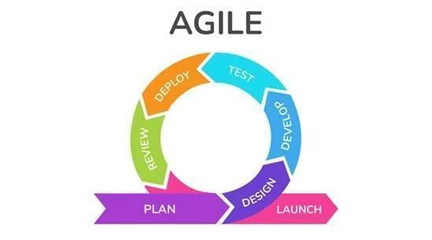
Figure 3.1. Agile Development Cycle Used in the Study
This study strictly utilizes the Agile Scrum software development methodology to engineer the cloud-based platform. Scrum is an iterative and incremental framework that is highly effective for managing complex software development where user requirements may evolve as functional prototypes are exposed to the target environment. Unlike the linear Waterfall model, or the purely continuous flow of Kanban, Scrum provides a highly structured cadence through fixed-length development cycles known as Sprints. Agile Scrum is appropriate because the proposed system must be refined through repeated user feedback and because SME requirements may become clearer as the prototype evolves. Studies on software development show that Agile Scrum supports responsiveness, collaboration, and continuous improvement, particularly in projects where user needs shape product features during development (Beck et al., 2001; Mishra & Alzoubi, 2023; Strode et al., 2022).
Plan. The researchers will consolidate findings from the baseline study and identify system goals, functional requirements, user roles, and scope boundaries.
Design. The researchers will prepare the database structure, interface layout, process flow, and security controls such as authentication and access separation.
Develop. The prototype modules for point-of-sale processing, inventory management, dashboard monitoring, and reporting will be coded incrementally so that each component can be reviewed and improved.
Test. Each iteration will undergo functional testing to verify the correctness of transaction recording, inventory updates, and report generation and to identify errors that require correction.
Deploy. A working prototype will be placed in a controlled environment for user interaction and operational evaluation.
Review. User feedback and validator comments will be gathered and used to refine the prototype before final evaluation.
Launch. The finalized version will serve as the completed system output of the study and the basis for the acceptability assessment.

Conceptual Framework
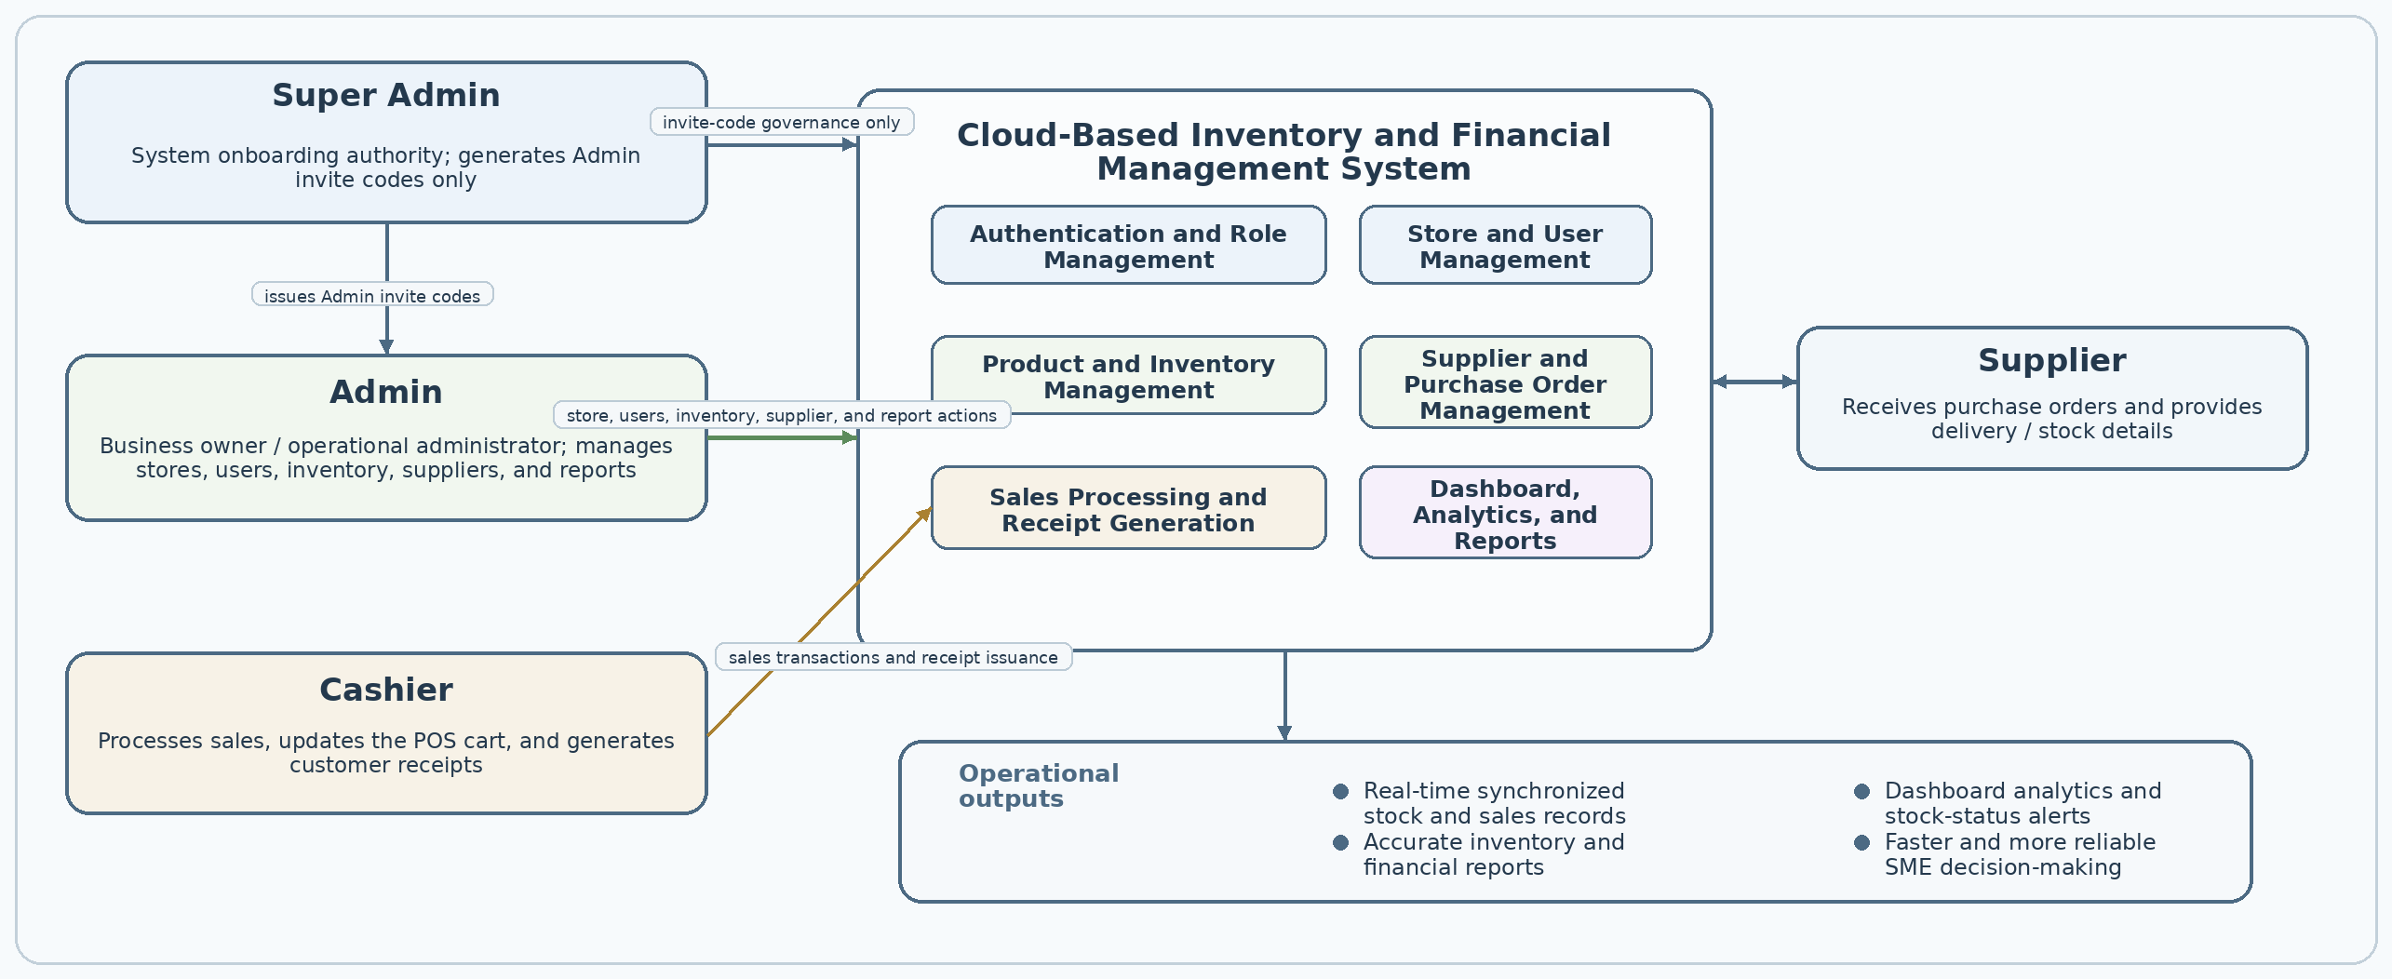
Figure 3.2. Conceptual Framework of the Kodigo System
Figure 3.2 presents the conceptual framework of the developed Kodigo Cloud-Based Inventory and Financial Management System. Outside the day-to-day operational workflow is the Super Admin, whose role is limited to generating invite codes used for Admin account creation and who does not participate in business operations. Admin users function as business-owner accounts and supervise store setup, user access, product and inventory records, supplier and purchase-order activities, and dashboard and report review. Inventory personnel maintain product, base-unit stock, restocking, and inventory-report workflows, while Cashiers operate the point-of-sale functions by processing sales and generating receipts.
Within the central cloud-based platform, these roles interact with shared modules for authentication, MFA, user and role management, inventory control, supplier coordination, sales processing, reporting, and bounded offline queueing. Supplier information and delivery details are recorded by authorized staff through internal supplier and purchase-order workflows; the system does not implement an external supplier portal. Connected processing maintains the authoritative base-unit stock and transaction records, while reports and analytics are derived from recorded data. The framework therefore shows both the hierarchy of roles and the flow of information needed to maintain one centralized and auditable source of truth.

Software Development Tools
The software development tools were selected to support the complete life cycle of the implemented web-based system, from interface design and application coding to backend services, version control, reporting outputs, and visual styling. Their combined use enabled the researchers to translate user requirements into a functional application, manage changes across iterative cycles, and maintain a consistent development environment. Table 3.4 presents the tools used and their specific roles in development.
Software | Description | How it was Used
Visual Studio Code   | A source-code editor used for writing and organizing project files. | Used as the primary development environment for the React/Vite frontend, Supabase-related code, SQL migrations, and documentation.
React | A JavaScript library for building component-based web interfaces. | Used to implement the authenticated application pages, POS, inventory, supplier, reporting, analytics, and settings views.
TypeScript and Vite   | TypeScript provides typed application code; Vite provides the development server and production build pipeline. | Used to type, bundle, and build the React application for local development and deployment.
Supabase   | A managed backend platform providing PostgreSQL, Auth, Row Level Security, Storage, Edge Functions, and database access. | Used as the authoritative backend for profiles, stores, products, suppliers, purchasing, sales, receipts, reporting, MFA assurance, and protected server operations.
Zustand and IndexedDB | Zustand manages client state; IndexedDB stores bounded browser caches and offline queues. | Used for authentication/store/cart/product state and for product caching plus queued POS or generic mutations during connectivity interruptions.
jsPDF and write-excel-file | Client-side libraries for document and workbook generation. | Used for receipt PDF downloads and administrative XLSX report export; inventory-oriented reports also support CSV export.
GitHub | A version-control and collaboration platform. | Used to track source changes and maintain the development repository.
Tailwind CSS | A utility-first CSS framework for responsive interface styling. | Used to style the web application with consistent spacing, typography, colors, states, and responsive layouts.
Vercel | A deployment platform configured for the single-page application. | Used through the SPA rewrite configuration so application routes resolve correctly after deployment.
Table 3.4. Software Development Tools

Project Features
Feature | Description
Role-Based Access Control | Supports Super Admin, Admin, Cashier, and Inventory roles with separated permissions. Super Admin handles invite-code governance; Admin manages assigned-store operations; Cashier handles POS; Inventory manages products, stock, and inventory-oriented reports.
Authentication System | Provides Supabase email/password login, invite-based owner registration, password reset, protected routes, and TOTP MFA/AAL2 assurance for enrolled accounts and protected operations.
Transaction Processing (POS) | Enables server-validated sales using product name/SKU/barcode search, configured selling options, base-unit stock deduction, supported payments, discounts, receipt snapshots, and transaction lifecycle controls.
Barcode and Manual Product Search | Allows products to be retrieved using barcode scanning or manual input.
Cart Management | Supports adding, updating, and removing items during a transaction.
Payment and Receipt Generation | Accepts cash, GCash, card, bank transfer, and other configured payment records; validates cash tender/change and generates printable or downloadable receipt snapshots.
Hardware Integration | Supports browser printing, thermal/A4 or PDF receipt output, barcode input, and optional Web Serial cash-drawer opening; external hardware availability remains environment-dependent.
Product Information Management | Stores product identity, SKU, barcode, category, supplier links, base unit, restocking options, selling options, cost, price, thresholds, margins, and archive state.
Stock Monitoring | Tracks base-unit quantity on hand, minimum/safety/reorder thresholds, lead time, low/critical/out-of-stock states, and sales-velocity indicators.
Stock Adjustment | Allows authorized base-unit stock adjustments with movement/audit records and controlled server-side validation.
Bulk-to-Piece Conversion | Supports configured pack/box/case/tray receiving conversions and unit or bulk/package selling options that share the product’s base stock; bulk discounts may be percentage-based or fixed-amount.
Audit Trail Logging | Records inventory movements, transaction events, price history, receipt snapshots, and other protected system changes for review.
Supplier Management | Maintains supplier records, assigned-store links, product-supplier relationships, lead times, order history, and derived performance scores.
Restock Recommendations | Suggests replenishment quantities from current stock and reorder thresholds and presents velocity/restock classifications; it is descriptive rather than predictive AI.
Purchase Order Preparation | Groups restocking requirements by supplier/store, creates purchase orders, records receiving, and converts received package quantities into base units.
Supplier Evaluation | Evaluates suppliers based on pricing and reliability.
Dashboard Overview | Displays today’s net revenue, transactions, average order value, gross profit, seven-day trend, recent transactions, stock alerts, and recent best sellers by net revenue.
Sales Analytics | Provides period, payment, and status filters with net sales, transactions, average order value, gross profit, hourly/category/selling-option breakdowns, transaction history, and export support.
Product Ranking | Ranks products and selling options for selected periods using revenue, base units, gross sales, discounts/returns, and profit.
System Settings | Allows authorized Admin users to configure store information, tax and receipt/branding fields, users, notification preferences, and security settings within assigned privileges.
Sales and Inventory Reports | Provides admin sales, inventory, stock-movement, restock-history, and price-history reports; inventory users receive inventory-oriented reporting. Admin reports support XLSX export and inventory reports support CSV export.
Notifications and Alerts | Records stock, sale, error, daily-summary, milestone, and report-export notifications with user preference/state handling.
Offline Queueing | Caches products and queues supported POS or generic mutations in IndexedDB for replay after connectivity returns; full offline reporting and automatic conflict resolution are outside scope.
Historical Snapshots and Price History | Preserves sale-item, receipt, cost, selling-price, and related historical values so later product or price edits do not rewrite completed records.
Product Archiving | Uses active/archive state for products with history and prevents destructive deletion when retained sales records require the product to remain auditable.
Table 3.5. Project Features
Table 3.5 presents the project features of the developed Cloud-Based Inventory and Financial Management System. The system supports four authenticated operational roles: the Super Admin, who handles invite-code governance for Admin onboarding; the Admin, who oversees assigned store or branch operations; the Cashier, who handles sales transactions; and the Inventory role, which manages products, stock, restocking, and inventory-oriented reports. Core features integrate point-of-sale processing, base-unit inventory control, supplier and purchase-order workflows, audit/history records, notifications, and dashboard reporting within one cloud-based platform.
Overall, the platform serves as a centralized solution that integrates sales, inventory, supplier management, purchasing, reporting, and descriptive analytics within a single cloud-based system. The role structure separates invite governance, store administration, inventory work, and transaction processing, while the modules use shared server-authoritative records. Bounded offline queueing improves continuity for supported operations, but full offline conflict resolution and predictive AI remain outside the present design.

Use-Case Diagram
A use case diagram is an important tool for visualizing the functions of a system and showing the interactions between users and the system. It helps present the system’s functional requirements in a clear and organized manner, making it easier to understand the roles of users and the services the system provides. This is essential in supporting effective system design and improving communication among stakeholders.
According to Rahayu et al. (2021), use case diagrams provide a clear visual representation of user requirements, helping developers better understand the goals and workflows of the system. Similarly, Yulianto et al. (2020) state that use case diagrams support system development by identifying functional boundaries, promoting clarity, and reducing the risk of scope creep. Through this, use case diagrams encourage better collaboration between technical and non-technical stakeholders, which contributes to the development of a more organized, user-centered, and efficient system.
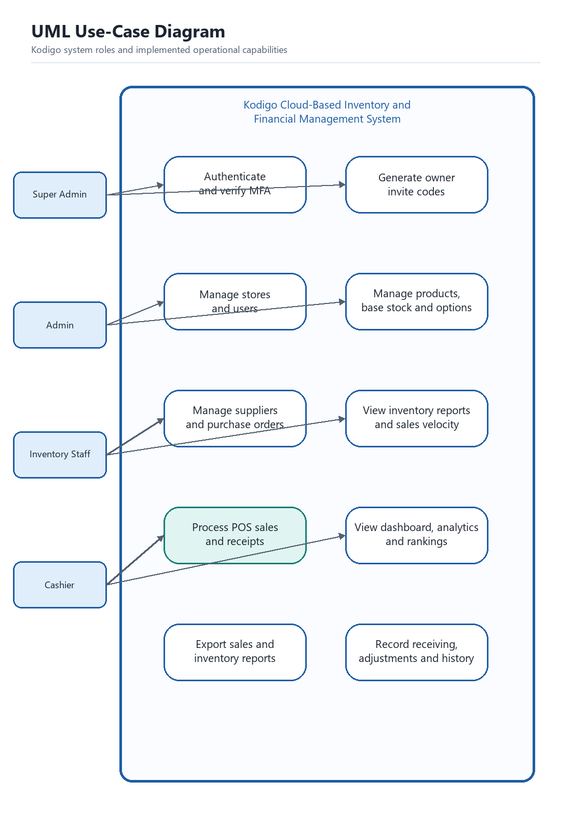
Figure 3.3. UML Use-Case Diagram of the Kodigo System
Figure 3.3 presents the UML use-case diagram of the Kodigo system. The diagram identifies four human roles: Super Admin, Admin, Inventory Staff, and Cashier. The roles authenticate through the protected access flow, with MFA assurance applied when configured. The Super Admin is linked only to Generate Owner Invite Codes, which supports Admin onboarding and separates the role from daily business operations. The Admin manages stores, users, products, suppliers, purchase orders, dashboards, analytics, and reports within assigned scope. Inventory Staff manage products, base-unit stock, restocking, and inventory-oriented reports. Cashiers process POS sales and receipts. Together, the use cases represent the implemented role separation and shared operational records.

Context Flow Diagram
A context flow diagram provides a high-level view of the system boundary by showing the human roles and operational information that exchange data with the Kodigo platform. Supplier information is represented as an internal business record rather than as a separate supplier-facing system.
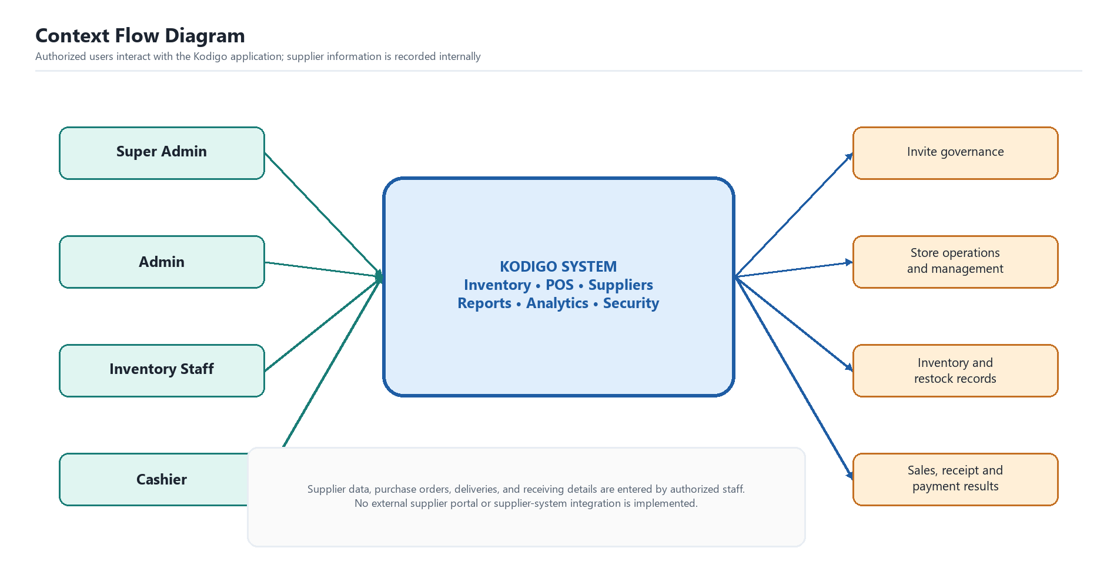
Figure 3.4. Context Flow Diagram of the Kodigo System
Figure 3.4 presents the context flow diagram of the developed Cloud-Based Inventory and Financial Management System. The system is shown as a central process connected to Super Admin, Admin, Inventory Staff, and Cashier roles. The Super Admin requests invite-code generation and receives onboarding status. The Admin manages stores, users, products, inventory, suppliers, purchase orders, dashboards, alerts, analytics, and reports within assigned scope. Inventory Staff maintain product and stock records and receive inventory-oriented views. Cashiers submit sales transactions and receive confirmations and receipts. Supplier names, contacts, purchase orders, deliveries, and receiving details are entered by authorized staff as internal records; no external supplier portal or supplier-system integration is implemented.

Data Flow Diagram
A data flow diagram shows how data move through the major processes, data stores, and external entities of the proposed system.
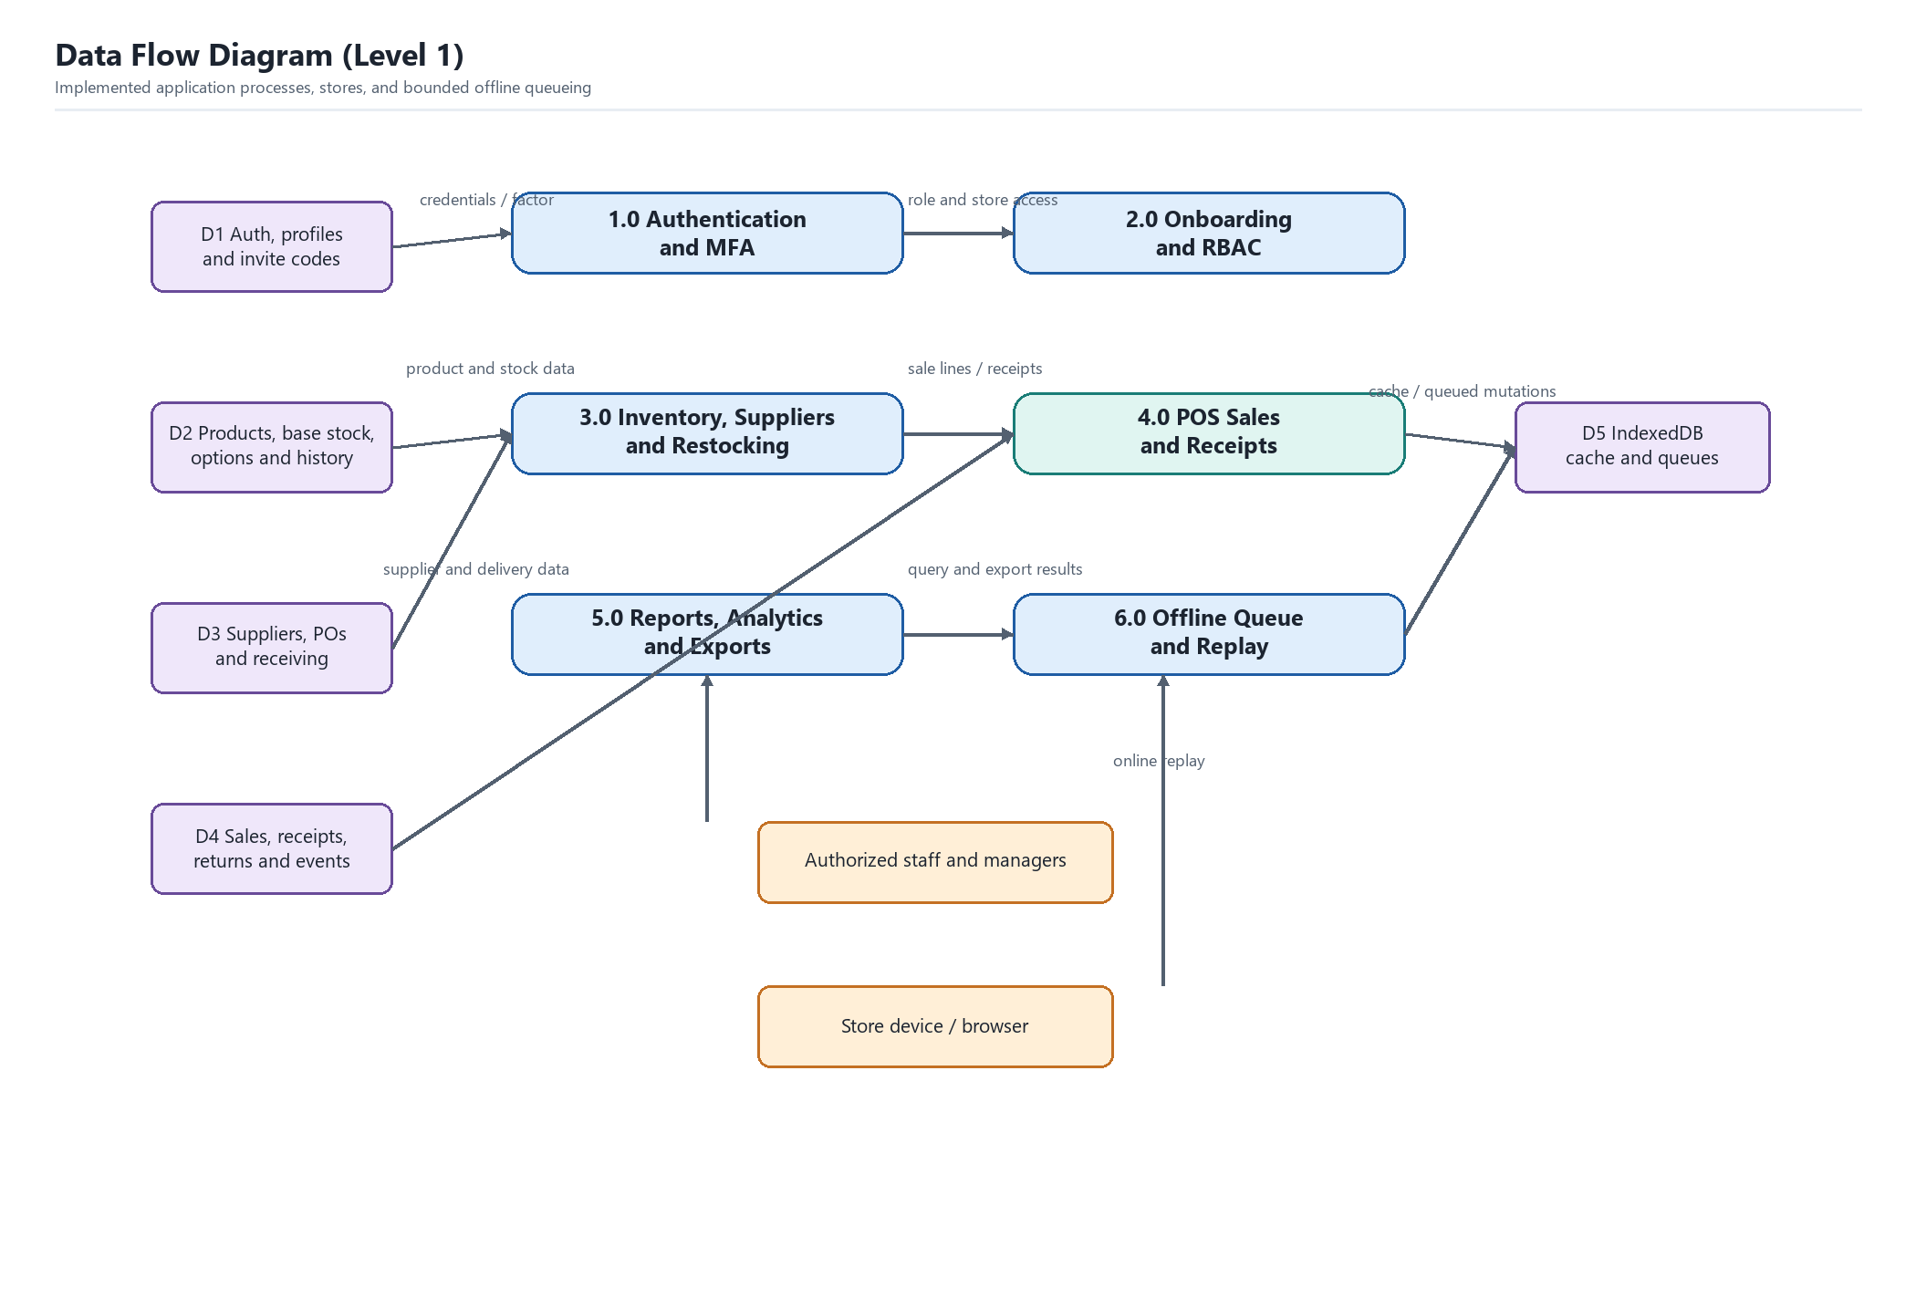
Figure 3.5. Data Flow Diagram (Level 1) of the Kodigo System
Figure 3.5 presents the level-1 data flow diagram of the developed Kodigo system. The diagram decomposes the platform into authentication and MFA, onboarding and role enforcement, inventory/supplier/restocking, POS and receipt processing, reports/analytics/exports, and bounded offline queue/replay. Credentials and factors are validated through protected authentication services; role and store access are enforced through application guards, server-side functions, and database policies. Product, base-unit stock, selling-option, supplier, purchase-order, and receiving data are persisted in the corresponding stores. Cashier sales are server-validated, write sale and receipt records, and update authoritative inventory values. Reports and analytics read recorded transaction, stock, history, and notification data. When supported operations encounter connectivity loss, the browser stores bounded cache or mutation-queue data and replays it when connectivity returns. The diagram does not imply a supplier portal or automatic conflict resolution.

Mock-ups and Prototype
This section presents the visual mock-ups translated into the working prototype/application of the developed Cloud-Based Inventory and Financial Management System. The figures are arranged according to the actual flow of system use, beginning with account creation and access, followed by administrative configuration, daily operational modules, transaction processing, and reporting views. Each figure is accompanied by an explanation of how the page works and how validation is applied to maintain data integrity, role separation, and secure system use.

Account Creation and System Access. The sequence begins with the pages used to register the owner account and authenticate authorized users before they can enter the operational modules of the system.

Figure 3.6. Admin Onboarding Page
Figure 3.6 presents the Admin onboarding page of the implemented system. This interface is used by the business owner to create the initial Admin account after receiving an invite code generated by the Super Admin. The page captures the full name, email address, password, and Admin invite code before access to the main application is granted. The page functions as a controlled registration gateway for the business-owner Admin account that will manage store operations and authorized users. Validation takes place by requiring complete field entry, checking the email structure, enforcing password input, and rejecting account creation when the invite code is missing or invalid.


Figure 3.7. Login Page
Figure 3.7 presents the login page used by the Super Admin, Admin, Inventory, Cashier, and other authorized staff accounts. After a registered email address and password are entered, the system authenticates the account and redirects the user to the modules permitted by the assigned role. The page also provides a password visibility control and a direct path to the Admin onboarding flow during first-time setup when a valid invite code has been issued. Validation occurs by requiring both credentials, checking them against stored account records, and preventing access when the combination is incorrect, incomplete, or unauthorized.
Administrative Configuration. After access is granted, the administrator configures store records, user access, notification preferences, and security settings to prepare the system for daily operations.
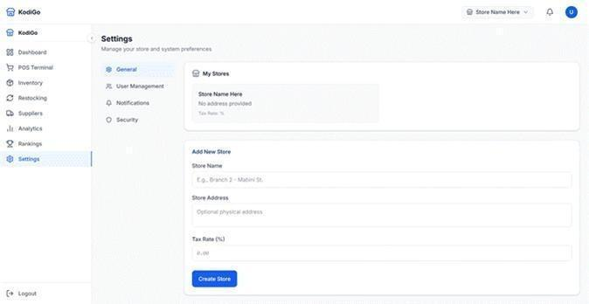
Figure 3.8. General Settings Page
Figure 3.8 presents the general settings page where an authorized Admin manages store information and creates new store entries. The upper panel displays the stores already registered in the system, while the lower form captures the store name, address, and applicable tax rate for a new branch or selling location. This page serves as the foundation of store-based record keeping because inventory, users, and reports are linked to a selected store. Validation occurs by requiring the store name, limiting tax-rate input to numeric values, and blocking incomplete store records from being saved.
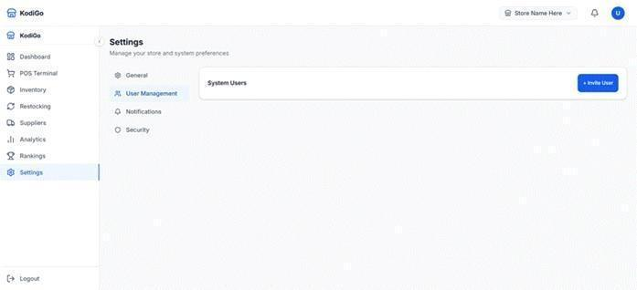
Figure 3.9. User Management Page
Figure 3.9 presents the user management page of the system. This page lists registered users for the selected store and supports store-level user administration. Admin users use this area to create and manage authorized Admin, Cashier, and Inventory personnel within their assigned operational scope. Validation takes place through role-based access control, server-side authorization, store assignment checks, and MFA assurance requirements for protected management operations.
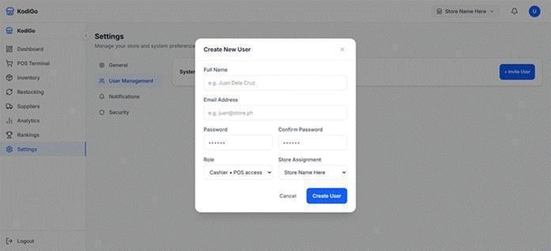
Figure 3.10. Invite User Modal
Figure 3.10 presents the invite user modal that appears when an authorized administrative user creates a new system account. The form captures the full name, email address, password, password confirmation, role, and store assignment so that the account can be linked to the proper operational scope. When used by an Admin, the modal supports authorized Admin, Cashier, and Inventory accounts within assigned stores. Validation requires essential fields, checks the email format, confirms matching passwords, and ensures that a valid role and store assignment are selected before the protected management function is called.
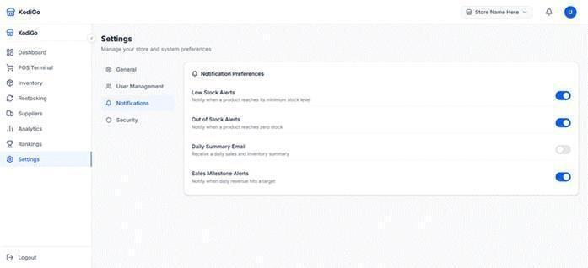
Figure 3.11 presents the notification preferences page. Through this interface, the administrator can manage preferences for low-stock, out-of-stock, daily-summary, sales-milestone, and related system notifications. The application also records sale, error, and report-export notification events for in-app review. Validation accepts only valid preference states and stores settings under the authenticated user and store context.
Figure 3.11 presents the notification preferences page. Through this interface, the administrator can enable or disable low-stock alerts, out-of-stock alerts, daily summary emails, and sales milestone alerts according to operational needs. The page works through simple toggle controls so that important notifications can be adjusted without editing core business records. Validation takes place by accepting only valid on or off states for each preference and by storing the selected notification settings under the authenticated user and store context.
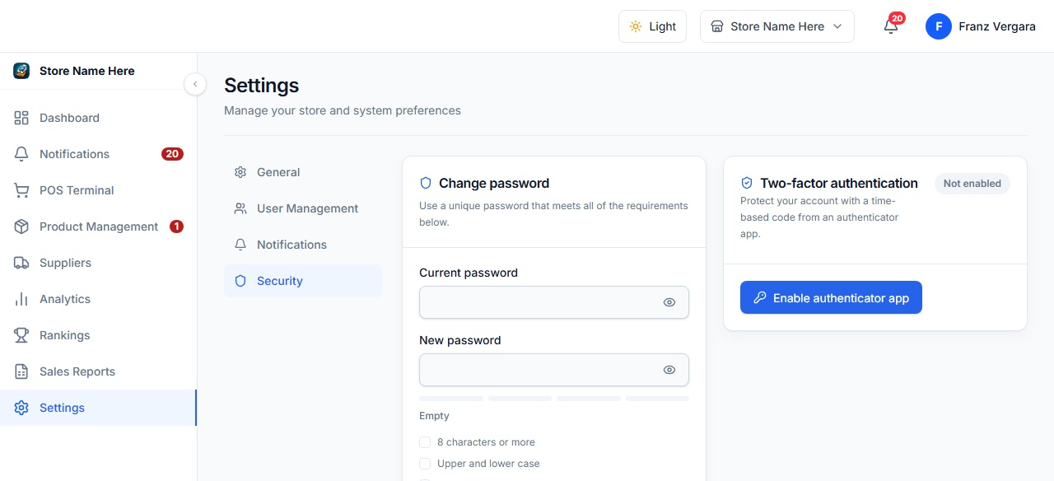
Figure 3.12. Security Settings Page
Figure 3.12 presents the security settings page used for password management and TOTP multi-factor authentication. The interface requires the current password, new password, and confirmation before a password update proceeds, and it provides the controls needed to enroll or verify an MFA factor when configured. Protected operations use the authenticated assurance level and role/store policies. Validation verifies credential changes, checks matching values, and rejects empty or inconsistent input before the update is accepted.
Operational Management and Inventory Control. Once the system is configured, the administrator can monitor the store, maintain product records, manage suppliers, and review replenishment requirements through the core operational pages.
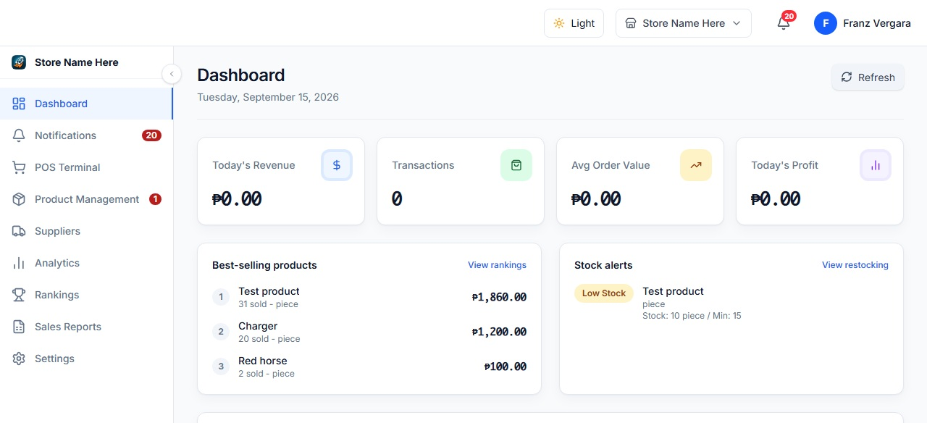
Figure 3.13. Dashboard Page
Figure 3.13 presents the dashboard page that summarizes the current state of store operations. It shows today’s net revenue, number of transactions, average order value, gross profit, seven-day best-selling products ranked by recent net revenue, stock alerts, a seven-day sales trend, and recent transactions, while allowing the user to refresh displayed values. The page works as the administrator’s main monitoring view after login. Validation is reflected in the way metrics are derived from recorded transactions and selected-store data rather than from manually editable summary values.
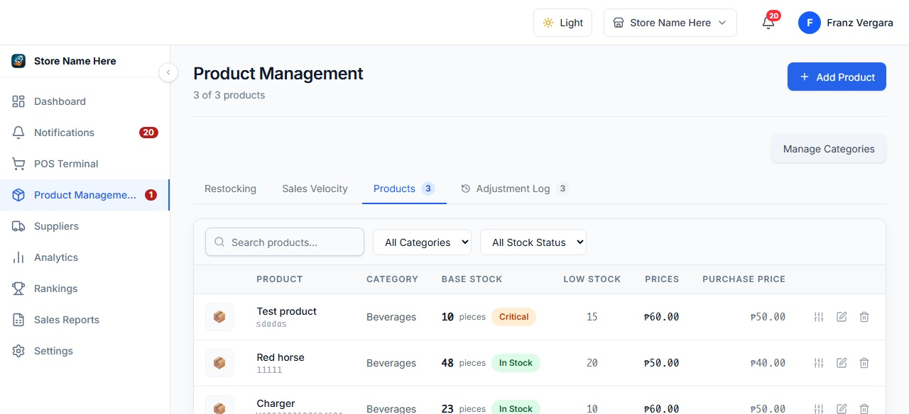
Figure 3.14 presents the inventory list page of the system. The page allows authorized Admin and Inventory users to search products, filter records by category and stock status, and review current base-unit QOH, thresholds, selling price, and cost. It provides access to controlled adjustment, editing, archiving, velocity, and product-detail actions. Validation applies search and filter criteria without changing source records and routes stock changes through protected record-management functions.
Figure 3.14 presents the inventory list page of the system. The page allows the administrator to search products, filter the records by category and stock status, and review stored details such as current stock, minimum stock, selling price, and cost. It works as the central index of encoded products and provides access to supporting actions such as adjustment, editing, and deletion. Validation takes place by displaying product status based on stored stock values, applying search and filter criteria without altering the original records, and routing maintenance actions through controlled record-management functions.
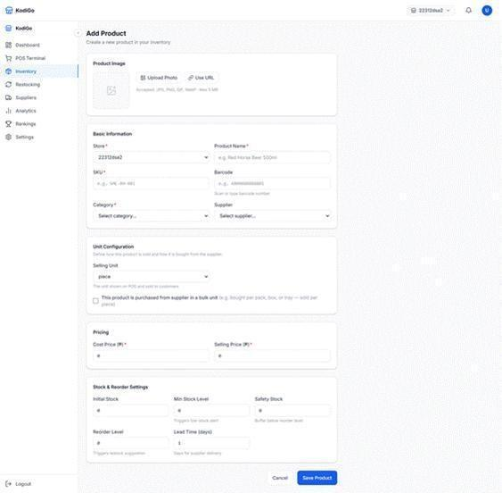
Figure 3.15. Add Product Page
Figure 3.15 presents the add product page used to encode a new item into inventory. The form collects product identity, store assignment, SKU, barcode, category, supplier links, base-unit configuration, cost, selling price, stock and reorder settings, restocking options, and selling options. A product can be received in configured package formats such as a pack, box, case, or tray and converted to base units; selling options share the same base stock. Bulk pricing can use fixed or percentage rules, while margin-assisted pricing and rounding can help prepare a suggested price. Validation uses required fields, accepted image types, and numeric controls for prices, stock, conversion factors, thresholds, and lead time.
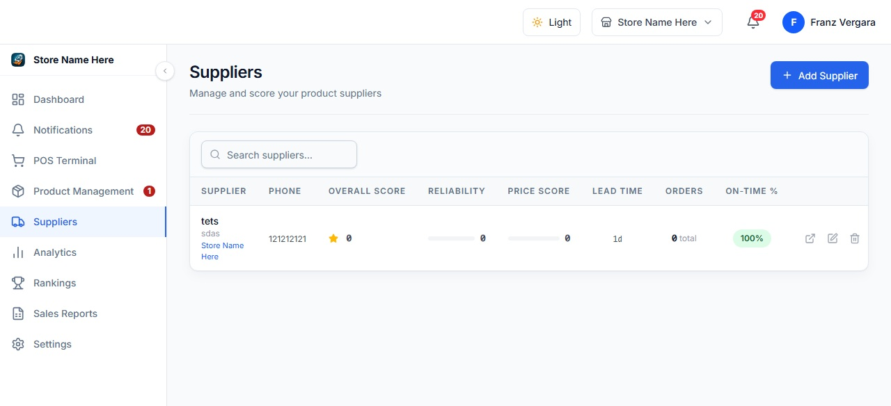
Figure 3.16. Suppliers Page
Figure 3.16 presents the suppliers page, which serves as the main listing for supplier records. The page allows authorized users to search suppliers and review operational measures such as overall score, reliability, price score, lead time, order count, and on-time percentage. Suppliers can be linked to multiple assigned stores and products, and the indicators are derived from stored purchasing data rather than manually entered on the list. The page also provides controlled supplier actions subject to role and store policies.
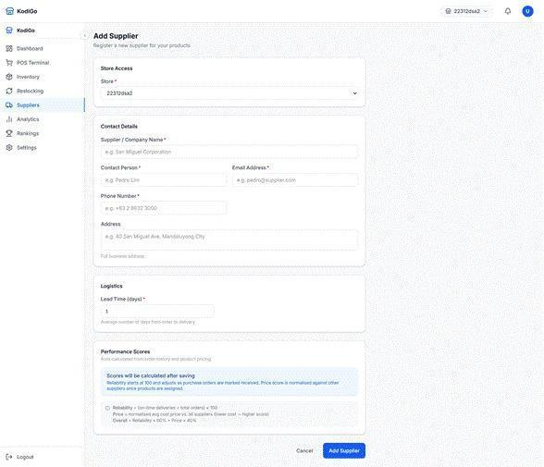
Figure 3.17. Add Supplier Page
Figure 3.17 presents the add supplier page used to register a supplier and assign it to permitted stores. The form captures supplier or company name, contact person, email, phone number, business address, lead time, and related contact information. The lower panel explains that performance scores are calculated after transactions have been recorded. Validation requires key fields, checks email and phone formats, enforces numeric lead-time input, and prevents users from manually entering system-derived performance scores.

Figure 3.18. Restocking Page
Figure 3.18 presents the restocking page. This interface compares current base-unit stock against stored minimum, safety, and reorder values and identifies products that may need replenishment. It supports suggested quantities, supplier-grouped purchase orders, configured restocking-unit conversions, receiving, and cost/history updates. Receiving a pack, box, case, tray, or other configured unit converts the delivery to base units and calculates a suggested selling price; it does not silently change the live selling price. Validation requires eligible low-stock records and authorized store/supplier access before replenishment actions proceed.

Point-of-Sale Transaction Flow. After master records have been prepared, the cashier-facing page supports the actual sales transaction by allowing fast product search, quantity adjustment, and payment processing.
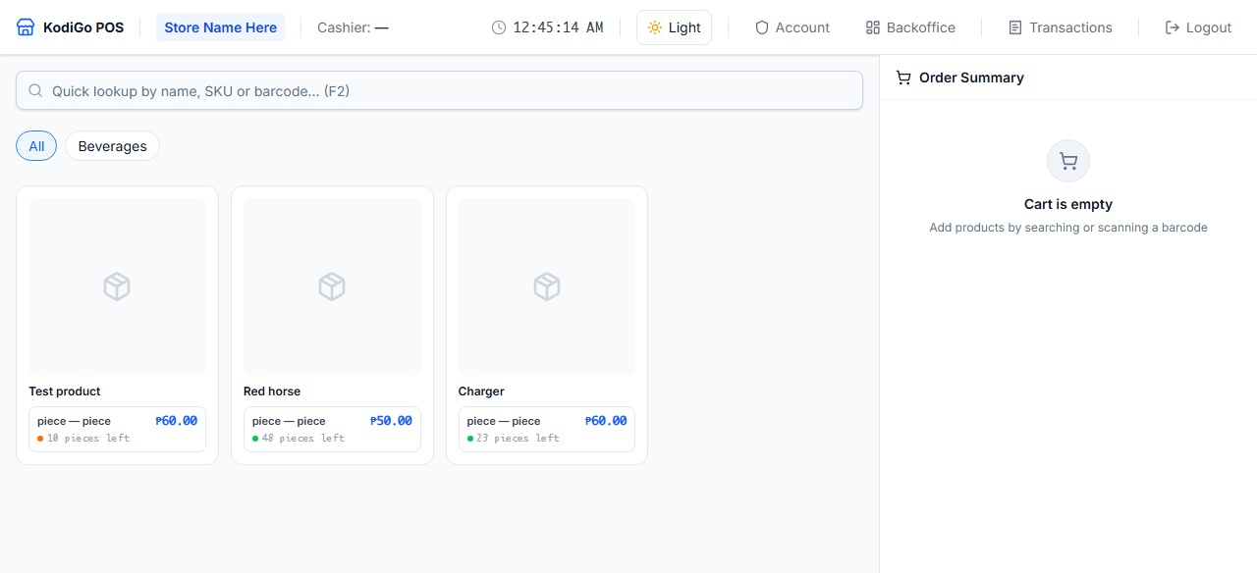
Figure 3.19. Point-of-Sale Page
Figure 3.19 presents the point-of-sale page used during actual sales transactions. The interface allows the cashier to search products by name, SKU, or barcode, select configured unit or bulk options, filter available items, add products to the cart, adjust quantities, apply supported discounts, and proceed to payment. The server validates role/store access, product prices and options, stock availability, discount/tax values, and tendered cash before recording the sale. Completed sales deduct shared base-unit stock and preserve sale-item and receipt snapshots. Supported payment records include cash, GCash, card, and bank transfer; supported POS mutations can be queued in the browser during connectivity interruptions.

Monitoring and Performance Reporting. After transactions have been recorded, the system summarizes the resulting operational data through analytical and ranking views intended to support managerial decision-making.
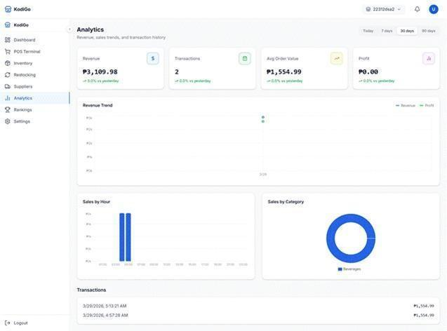
Figure 3.20. Analytics Page
Figure 3.20 presents the analytics page of the system. The page provides Today, 7-day, 30-day, 90-day, and custom-period filters, together with payment and transaction-status filters. It displays net sales, transactions, average order value, gross profit, revenue trend, sales by hour, category and selling-option breakdowns, and recent transaction views. The page is a descriptive reporting tool derived from recorded transaction data for the active store or permitted store scope; it does not provide AI forecasting. Export and refresh actions are available according to role and report scope.
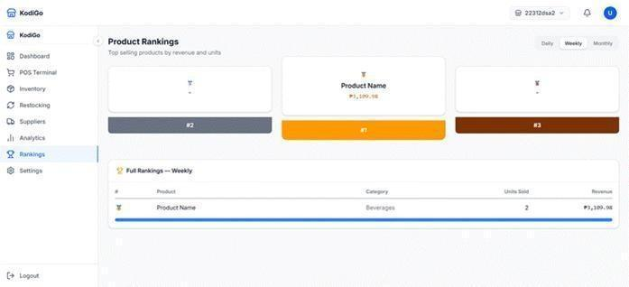
Figure 3.21 presents the product rankings page. The interface supports today, week, month, and custom reporting periods, highlights top products or selling-option combinations in a podium-style layout, and provides a full table containing base units, net revenue, gross sales, discounts and returns, and profit. This page is a descriptive comparison tool for identifying top-performing items and product contribution to sales. Rankings are derived automatically from stored sales records for the selected period rather than arranged manually.
Figure 3.21 presents the product rankings page. The interface shows daily, weekly, and monthly ranking views, highlights the top three products in a podium-style layout, and provides a full table containing the product name, category, units sold, and generated revenue. This page works as a quick reference for identifying top-performing items and comparing product contribution to sales. Validation occurs by deriving the rankings automatically from stored sales records and by refreshing the displayed order of products according to the selected reporting period rather than through manual arrangement.

Data Analysis Tools and Techniques
The collected data will be analyzed using qualitative and quantitative procedures consistent with the mixed-method structure of the study. The qualitative component will be analyzed through thematic analysis, while the quantitative component will be processed and visualized using Power BI supported by descriptive statistics. The use of both approaches enables the researchers to interpret lived operational experiences and measurable evaluation results in a complementary manner.
Interview responses will be transcribed, organized, and analyzed using thematic analysis. Following Braun and Clarke (2006) and the trustworthiness guidance of Nowell et al. (2017), the researchers will (1) familiarize themselves with the data, (2) generate initial codes, (3) search for candidate themes, (4) review and refine the themes, (5) define and name the themes, and (6) interpret the findings in relation to the research questions. This approach is appropriate because it allows recurring patterns in workflow problems and decision-making challenges to emerge directly from participant accounts rather than being imposed in advance. Thematic analysis will be used for the qualitative component of Research Question 1.
The quantitative responses from the baseline operational questionnaire, the technical validation survey, and the system acceptability survey will be encoded and imported into Power BI. Power BI will be used to organize the dataset, create calculated measures, and present the results through tables, indicator cards, bar charts, and other dashboard visuals. This tool is appropriate because business intelligence platforms improve the clarity of numerical findings and help transform survey results into decision-oriented visual summaries (Hurbean et al., 2023; Raihanto et al., 2023).
For the quantitative component of Research Question 1, Power BI will be used to present baseline descriptive results such as frequency and percentage distributions of current inventory tracking methods, occurrence of discrepancies, and time required for reconciliation. For Research Question 2, Power BI will be used to compute and visualize the mean and sample standard deviation of the technical validation ratings for the proposed system framework and information security measures. For Research Question 3, Power BI will be used to compute and visualize the mean and sample standard deviation of the acceptability ratings under the criteria of cost-effectiveness, system reliability, operational efficiency, and security.
The mean will be used to determine the average rating for each indicator and criterion, while the sample standard deviation will be used to determine the consistency of responses. The formulas to be used are presented below.
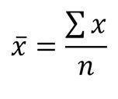
Figure 3.22. Mean Formula
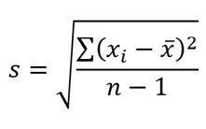
Figure 3.23. Standard Deviation Formula
Where:
x̄ = mean
Σx = sum of all responses
n = number of responses
s = sample standard deviation
xi = individual response value
Accordingly, thematic analysis will answer the qualitative component of Research Question 1, whereas Power BI will support the quantitative component of Research Question 1, the entirety of Research Question 2, and the entirety of Research Question 3. During interpretation, the researchers will compare the qualitative themes and quantitative patterns to determine whether the developed system addresses the diagnosed bottlenecks and supports better decision-making in SME operations.

CHAPTER 4

RESULTS AND DISCUSSIONS
This chapter presents, analyzes, and interprets the findings for Research Question 1, which sought to identify the key challenges and operational bottlenecks faced by small and medium enterprises in manual inventory tracking and error-prone financial reconciliation, particularly in terms of inaccurate inventory tracking, slow decision-making, high operational cost, and data inconsistency. The discussion integrates baseline pre-survey results from operational respondents and thematic analysis of interview transcripts. Taken together, the findings show that the central operational problem is not merely the use of manual tools, but the absence of one timely, trusted, and shared source of truth for stock movement, sales, pricing, and related financial records.

Response Rate
In the study's assessment of response rates, all intended operational respondents completed the pre-survey, and all identified interview transcripts for the qualitative strand were included in the thematic analysis. Specifically, for the quantitative portion, 18 out of 18 target participants completed the pre-survey, resulting in a 100.0% response rate. Similarly, the qualitative portion saw full participation, with 5 out of 5 target interview transcripts analyzed, also yielding a 100.0% response rate. This total participation provided full coverage of the available baseline quantitative data and the cross-case qualitative accounts used to answer Research Question 1.

Demographics
The pre-survey respondents represented both decision-making and day-to-day operational roles. Operations staff formed the largest group, followed by owners or managers, cashiers or sales encoders, and stock custodians. The distribution of years in role also indicates that the dataset reflects both relatively new and experienced personnel, allowing the chapter to capture operational bottlenecks from multiple perspectives. In addition, the operational profile already suggests fragmented workflows, since most respondents relied on a combination of two or more methods rather than a single integrated tool.
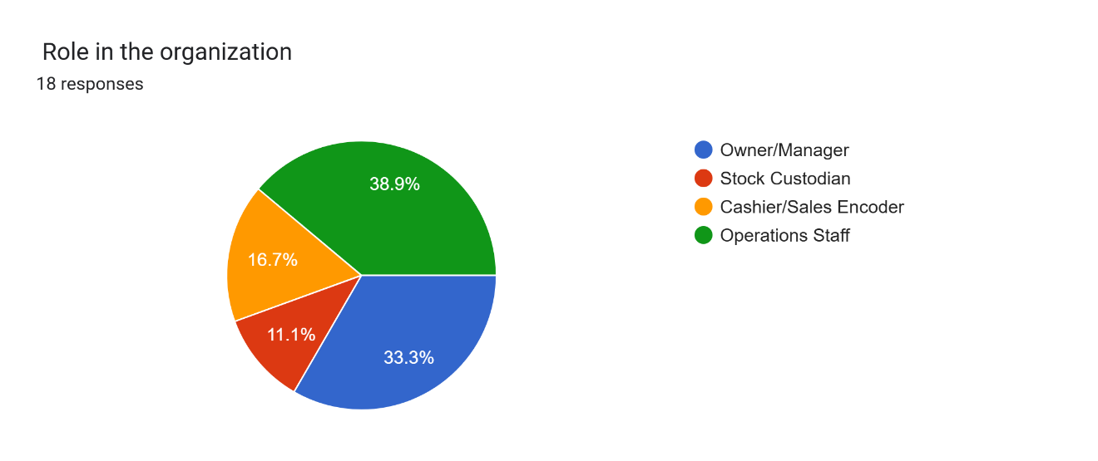
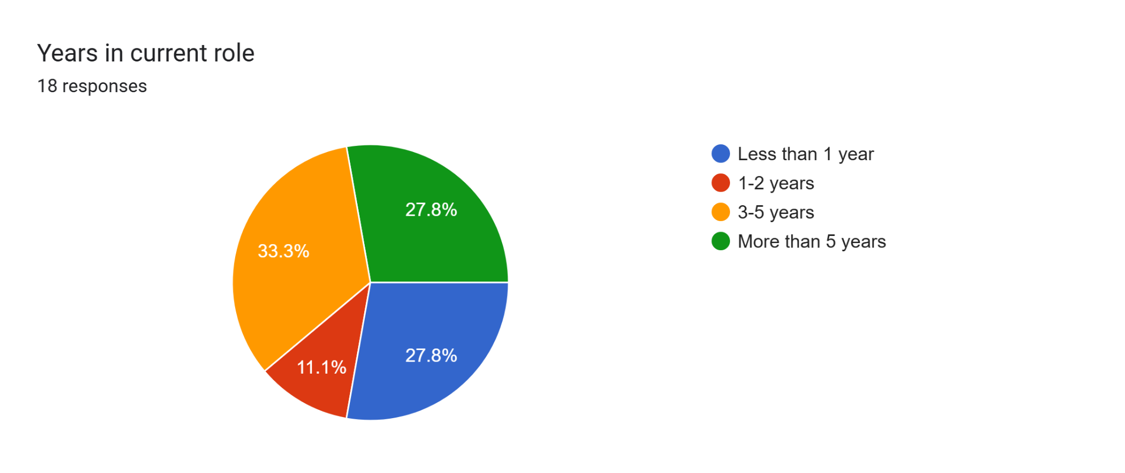
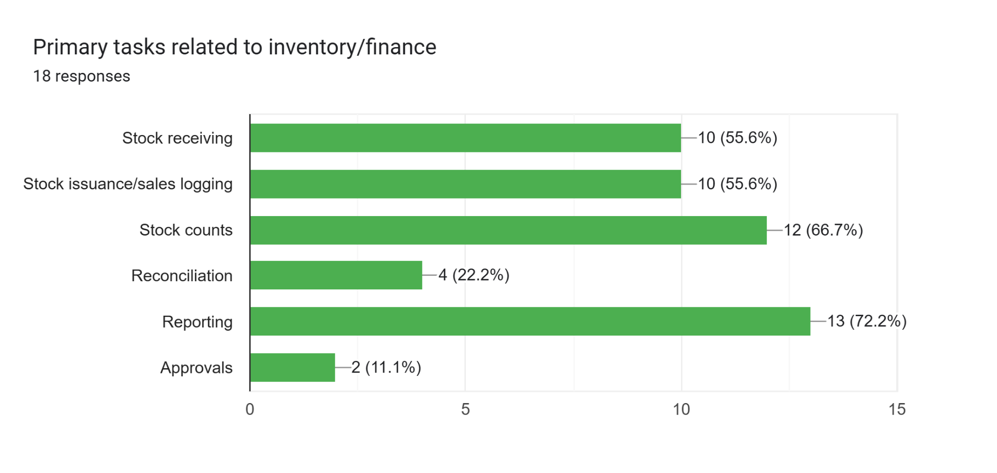
Figure 4.1. Demographic and Operational Profile of Pre-Survey Respondents

Findings for Research Question 1
Research Question 1 asked: What are the key challenges and operational bottlenecks faced by SMEs in manual inventory tracking and error-prone financial reconciliation processes, and how do these challenges affect overall efficiency in terms of inaccurate inventory tracking, slow decision-making, high operational cost, and data inconsistency? The quantitative findings establish the extent and frequency of the problem, while the interview data explain how these issues emerge in everyday work and why they persist.

Baseline workflow conditions from the pre-survey
The pre-survey results show that manual and fragmented processes remain deeply embedded in current SME operations. A majority of respondents (61.1%) reported using a combination of two or more methods, while another 33.3% still relied primarily on paper logbooks. Only one respondent reported spreadsheet use as the main method. This pattern indicates that most participating businesses do not operate with one continuously updated record; instead, they switch between notebooks, spreadsheets, POS outputs, receipts, and chat-based confirmations.
RQ1 Dimension | Key quantitative indicator | Result | Interpretation
Inaccurate inventory tracking | Inventory updates take 16 minutes or more after sale or issuance | 72.2% (13 of 18) | Stock data are commonly updated after a time lag rather than at the point of movement.
Inaccurate inventory tracking | Inventory discrepancies occurred three or more times in the past 30 days | 66.7% (12 of 18) | Discrepancies were recurrent rather than isolated events.
Slow decision-making | Incomplete or uncertain information delayed decisions at least sometimes | 88.9% (16 of 18) | Decision delays were a normal part of operations for most respondents.
Slow decision-making | Management receives a usable report one to five days after period end | 61.1% (11 of 18) | A substantial proportion still waits beyond the same day for decision-ready information.
High operational cost | Extra costs due to errors were incurred one to five times in a typical month | 100.0% (18 of 18) | Operational inefficiencies translated into repeated cost exposure such as rush buying, waste, or missed sales.
High operational cost | Each reconciliation cycle takes at least 30 minutes | 100.0% (18 of 18) | Reconciliation imposes a consistent labor burden on daily operations.
Data inconsistency | Records from different sources do not match at least sometimes | 100.0% (18 of 18) | Mismatch across logbooks, spreadsheets, POS reports, and receipts is a universal issue in the dataset.
Data inconsistency | Identifying the source of a discrepancy takes 30 minutes or more | 88.9% (16 of 18) | Mismatch resolution is time-consuming, which further delays correction and reporting.
Table 4.1. Key Baseline Indicators Related to Research Question 1
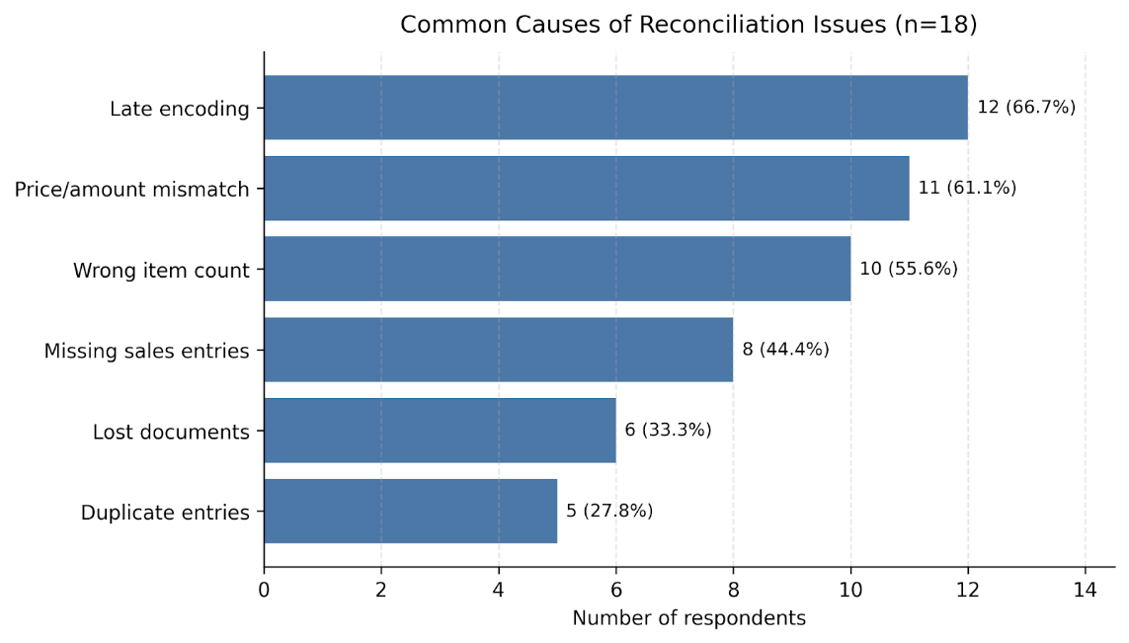
Figure 4.2. Common Causes of Reconciliation Issues Reported in the Pre-Survey
Note. Respondents could select more than one cause; percentages therefore total more than 100 percent.
Figure 4.2 shows that late encoding emerged as the most frequently reported cause of reconciliation problems (66.7%), followed by price or amount mismatches (61.1%) and wrong item counts (55.6%). Missing sales entries (44.4%) and lost documents (33.3%) further reveal that errors do not originate from one step alone. Instead, they accumulate across recording, updating, checking, and document handling. This strengthens the view that the problem is process fragmentation rather than a single isolated control failure.
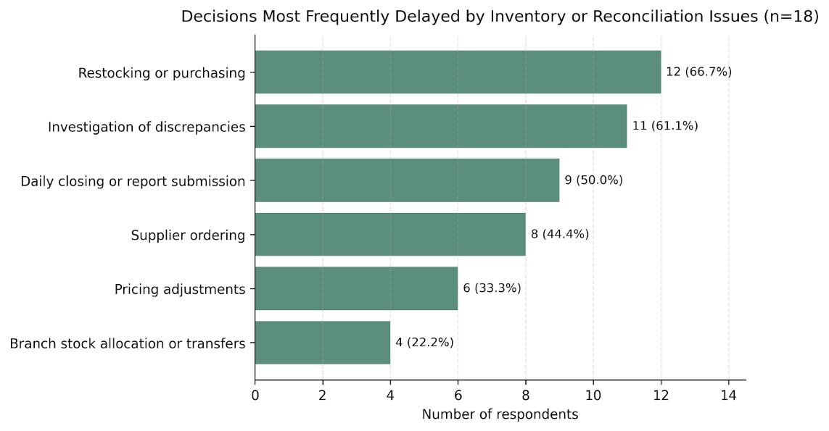
Figure 4.3. Decisions Most Frequently Delayed by Inventory or Reconciliation Issues
Note. Respondents could select more than one type of delayed decision.

Figure 4.3 indicates that the most affected decisions were restocking or purchasing (66.7%), investigation of discrepancies (61.1%), and daily closing or report submission (50.0%). Supplier ordering and pricing adjustments were also frequently delayed. These results show that slow information flow affects both immediate frontline operations and higher-level management tasks. The delay is therefore not confined to reporting; it also shapes whether businesses can replenish stock on time, confirm quantities, or respond quickly to emerging problems.

Perceived effects of the current workflow on efficiency
The perception-based items in the pre-survey reinforce the baseline indicators. Respondents were only neutral on whether their current process keeps stock records accurate throughout the day and whether inventory and financial records remain consistent across tools. In contrast, they agreed or strongly agreed that manual checking increases workload, reconciliation delays affect decision timeliness, and errors create avoidable costs.
Indicator | Mean | SD | Interpretation
Our current process allows stock records to stay accurate throughout the day. | 2.78 | 1.17 | Neutral
Inventory and financial records are consistent across the documents or tools we use. | 2.78 | 0.94 | Neutral
Manual checking and re-encoding increase workload in our operations. | 4.50 | 0.51 | Strongly Agree
Delays in reconciliation affect the timeliness of decisions in our organization. | 4.28 | 0.57 | Strongly Agree
Errors in inventory or reconciliation lead to avoidable operational costs. | 3.89 | 0.96 | Agree
Table 4.2. Mean Ratings on Current Workflow Conditions and Operational Effects
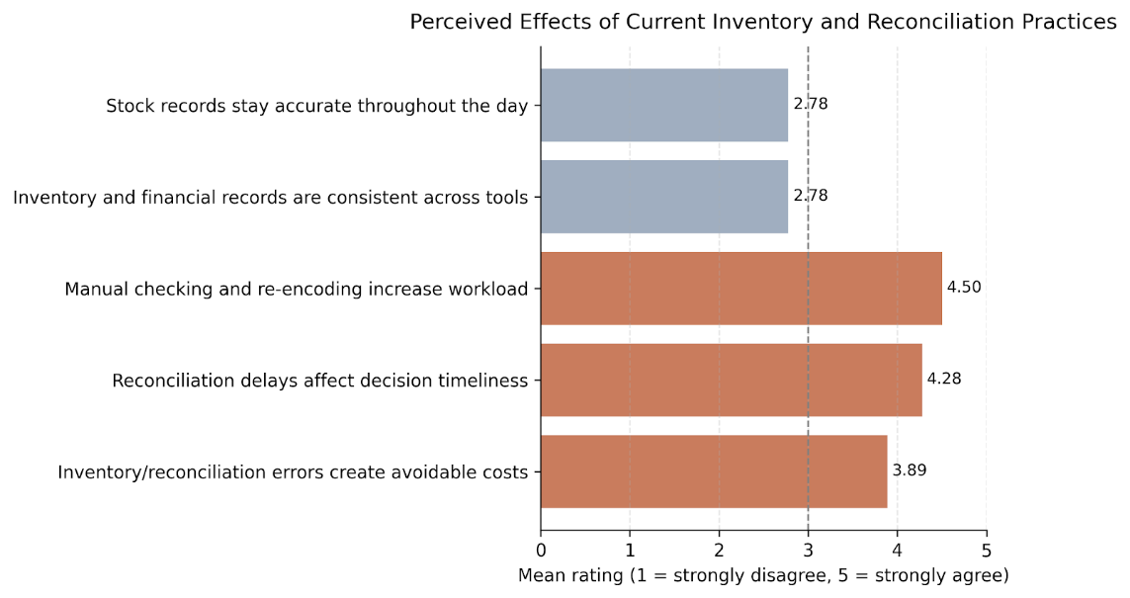
Figure 4.4. Mean Scores of the RQ1-Related Perception Items
As shown in Table 4.2 and Figure 4.4, the highest mean was recorded for the statement that manual checking and re-encoding increase workload (M = 4.50, SD = 0.51), followed by the statement that reconciliation delays affect decision timeliness (M = 4.28, SD = 0.57). The statement that inventory or reconciliation errors create avoidable costs also received a high mean (M = 3.89, SD = 0.96). By contrast, the two positively framed statements on accuracy and consistency both obtained lower means (M = 2.78), indicating that respondents did not strongly perceive their current workflow as dependable throughout the day. Taken together, the scale results show that the present workflow is experienced more as a burden to be corrected than as a reliable basis for decisions.

Qualitative themes from the interview transcripts
The qualitative strand explains the operational meaning behind the survey patterns. Five interview transcripts from different SME contexts were reviewed using thematic analysis. Although the businesses differed in size and industry, the same cross-case pattern appeared repeatedly: once stock, sales, pricing, transfers, or payment records were spread across multiple tools and people, the reliable picture of operations became delayed, uncertain, and dependent on rechecking.
Interviewee | Business context | Role | Notable process features
Interviewee 1 | Single-location micro-retail store | Owner/operator | Heavy reliance on memory; price verification depends on spouse; no formal stock system.
Interviewee 2 | Sari-sari store | Family store operator | Manual notebook logging; household use and credit sales complicate reconciliation.
Interviewee 3 | Two-branch neighborhood grocery | Owner-manager | Basic POS plus logbooks; branch transfers; mixed-unit selling; e-wallet settlements.
Interviewee 4 | Hardware and construction supplies | Operations/branch manager | POS, quotation sheets, warehouse release slips, and transfer forms.
Interviewee 5 | Bakery with commissary and outlets | Owner-manager / operations lead | POS by outlet, production logs, transfer sheets, wastage forms, and payment screenshots.
Table 4.3. Interview Participant Contexts Included in the Thematic Analysis
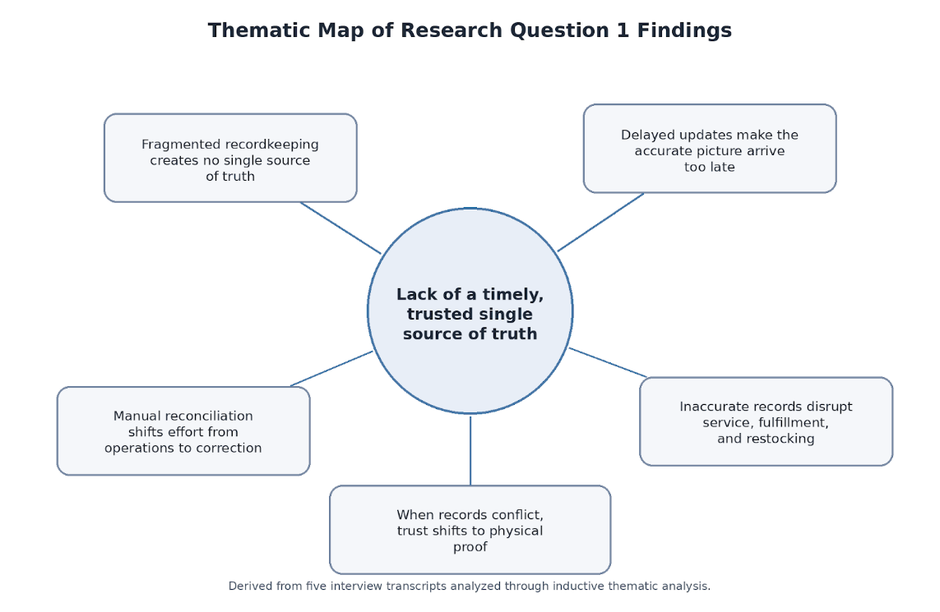
Figure 4.5. Thematic Map of the Qualitative Findings for Research Question 1
Figure 4.5 summarizes the thematic structure of the interview data. At the center is the lack of a timely, trusted single source of truth. From that central problem flowed five related themes: fragmented recordkeeping, delayed visibility of the true situation, disruption to service and restocking, labor shifted toward error correction, and greater trust in physical proof than in the shared record itself.

Theme | Core sub-themes | Illustrative quote | Meaning for operations
Fragmented recordkeeping creates no single source of truth | Manual and hybrid recording; person-dependent updates; informal workarounds. | "So far, we do not have a system for tracking our sales and inventory..." (Interviewee 1) | Operations depend on scattered records rather than a unified live record.
Delayed updates make the accurate picture arrive too late | Unposted movement; next-day correction; decisions made under uncertainty. | "The deeper issue is that the real situation becomes visible too late." (Interviewee 3) | Even when the truth is eventually reconstructed, it often arrives after the decision window.
Inaccurate records disrupt service, fulfillment, and restocking | Customer promise failure; partial release; conservative or delayed restocking. | "This can disappoint customers and reduce sales." (Interviewee 2) | Weak records quickly become visible as stockouts, delays, and missed sales.
Manual reconciliation shifts effort from operations to error correction | Repeated recounting; after-hours verification; coordination strain. | "Sometimes it ends up in an argument because I am already loaded with work." (Interviewee 1) | Labor is redirected from serving customers and planning toward repetitive correction.
When records conflict, trust shifts to physical proof | Physical count as truth; signed slips and receipts preferred; slow confirmation. | "We usually check the actual physical stock first because that is the most reliable basis." (Interviewee 2) | Record systems have not earned enough trust to support fast decisions on their own.
Table 4.4. Themes, Sub-Themes, and Illustrative Quotes from the Interview Data

Fragmented recordkeeping creates no single source of truth
The first theme shows that records are distributed across notebooks, spreadsheets, chat messages, POS summaries, receipts, and memory. In Interviewee 1’s account, inventory decisions depended largely on checking which items looked low and then contacting another person to verify prices. Similar fragmentation appeared in the grocery, hardware, and bakery cases, where branch transfers, release slips, production logs, or chat updates could exist separately from the main stock file. This directly reflects data inconsistency, because each tool contains only a partial version of the operational reality.

Delayed updates make the accurate picture arrive too late
The second theme highlights the timing problem. Interviewee 3 explained that the real situation often becomes visible too late, while Interviewee 5 emphasized that by the time all records are complete, the opportunity to adjust production, labor, or restocking may already be gone. This theme explains why survey respondents frequently reported delayed purchasing, report submission, and discrepancy investigation. The issue is therefore not merely whether the record becomes accurate eventually, but whether it becomes accurate in time to guide action.

Inaccurate records disrupt service, fulfillment, and restocking
The third theme connects data problems to visible operational outcomes. Interviewees described customers being told that stock was available when the shelf count said otherwise, partial releases for promised orders, and more cautious restocking because the numbers could not be trusted. In the hardware case, an incomplete record reduced the ability to commit materials to a contractor. In the bakery case, delayed information led to conservative production decisions and missed sales opportunities. These accounts show that inaccurate tracking weakens both service reliability and inventory responsiveness.

Manual reconciliation shifts effort from operations to error correction
The fourth theme clarifies why operational cost is not limited to direct cash loss. Interviewees repeatedly described overtime, repeated checking, recounting, follow-up calls, document chasing, and after-hours correction. Survey results mirror this pattern, since every respondent reported spending at least 30 minutes per reconciliation cycle and all respondents reported incurring extra costs due to errors at least once or twice in a typical month. The cost is therefore both monetary and organizational, because staff attention is diverted from serving customers and planning the business.

When records conflict, trust shifts to physical proof
The fifth theme reveals a trust deficit in the record system itself. When numbers do not match, respondents do not immediately trust the spreadsheet, notebook, or report; they return to physical counts, signed slips, delivery receipts, and screenshots. This explains why discrepancy tracing often takes 30 minutes or more. It also shows that the existing record structure does not yet function as a decision-ready source of truth. Instead, managers must repeatedly re-validate the record against physical evidence before acting on it.

Integrated discussion of the quantitative and qualitative findings
When the survey and interview results are interpreted together, a coherent picture emerges. The quantitative data show that the problems are frequent and consequential, while the qualitative data explain the mechanisms through which they occur. The integrated pattern is summarized in Table 3.5.

RQ1 dimension | Quantitative pattern | Qualitative explanation | Overall interpretation
Inaccurate inventory tracking | 72.2% updated inventory after 16 minutes or more; 66.7% experienced discrepancies three or more times in 30 days. | Stock movement is captured across notebooks, spreadsheets, chat messages, and person-dependent updates. | Tracking errors occur because transactions are not recorded in one place at the time of movement.
Slow decision-making | 88.9% reported that incomplete information delays decisions at least sometimes; 61.1% waited one to five days for usable reports. | The accurate picture is often reconstructed only after closing, recounting, or cross-checking. | Managers and staff act under uncertainty, so operations become reactive rather than planned.
High operational cost | 100.0% incurred extra costs monthly; 100.0% spent at least 30 minutes per reconciliation cycle. | Manual reconciliation generates overtime, repeated checking, emergency purchases, and missed sales. | Cost is created not only through losses, but also through the labor and disruption required to correct records.
Data inconsistency | 100.0% reported records that do not match at least sometimes; 88.9% needed 30 minutes or more to find the source of discrepancies. | When records conflict, businesses trust physical counts and signed proof more than the shared file. | The workflow lacks a dependable and auditable single source of truth.
Table 4.5. Integrated Summary of the Quantitative and Qualitative Findings for Research Question 1
Overall, the findings answer Research Question 1 by showing that the most critical operational bottleneck is the absence of a unified and timely record that can simultaneously support sales processing, stock visibility, and financial reconciliation. Inaccurate inventory tracking emerges when updates are delayed or scattered across tools. Slow decision-making occurs when staff must verify records before acting. High operational cost arises from rework, overtime, emergency replenishment, wasted effort, and missed opportunities. Data inconsistency persists because different documents or systems capture only fragments of the same event. The chapter therefore establishes a strong empirical basis for moving toward an integrated cloud-based system that can update records in real time, preserve audit trails, and reduce dependence on manual reconciliation.

Summary of Findings
The quantitative and qualitative findings converge on the same conclusion. Current SME practices are characterized by fragmented recordkeeping, delayed updating, repeated reconciliation, and weak confidence in the records used for decisions. Most respondents relied on multiple tools, experienced recurring discrepancies, and reported that the current workflow increased workload and delayed operational action. The interview data further showed that these problems are felt directly through stock uncertainty, slower replenishment, customer service disruption, and greater dependence on physical verification.
More specifically, the chapter found that inaccurate inventory tracking is sustained by delayed postings, missed entries, and multiple non-synchronized records. Slow decision-making arises because usable information is often available only after additional checking. High operational cost results from overtime, emergency buying, repeated counting, and missed sales. Data inconsistency persists because different sources of information do not align at the same time or with the same level of detail. These findings establish that the problem addressed in this study is both operational and informational: without a shared, timely, and trusted record, SMEs are forced to operate reactively instead of making confident, evidence-based decisions.

References
Ashrafuzzaman, M. (2024). The impact of cloud-based management information systems on HRM efficiency: An analysis of small and medium-sized enterprises (SMEs). Advances in Learning, Data Science and Management. https://doi.org/10.69593/ajaimldsmis.v1i01.124
Ayochok, J., & Perez, C. (2024). Enhancement of inventory management system of state universities and colleges in Mountain Province. East Asian Journal of Multidisciplinary Research, 3(10), 4627–4646. https://doi.org/10.55927/eajmr.v3i10.11278
Bano, M., Zowghi, D., Ferrari, A., Spoletini, P., & Donati, B. (2015). A systematic review on the relationship between user involvement and system success. Information and Software Technology, 58, 148–169. https://doi.org/10.1016/j.infsof.2014.06.011
Beck, K., Beedle, M., van Bennekum, A., Cockburn, A., Cunningham, W., Fowler, M., Grenning, J., Highsmith, J., Hunt, A., Jeffries, R., Kern, J., Marick, B., Martin, R. C., Mellor, S., Schwaber, K., Sutherland, J., & Thomas, D. (2001). Manifesto for Agile Software Development. Agile Alliance. https://agilemanifesto.org/
Braun, V., & Clarke, V. (2006). Using thematic analysis in psychology. Qualitative Research in Psychology, 3(2), 77–101. https://doi.org/10.1191/1478088706qp063oa
CloudCFO. (2025, September 1). Digital tools to automate payroll, bookkeeping, and tax filing in 2025. https://cloudcfo.ph/blog/digital-tools-to-automate-payroll-bookkeeping-and-tax-filing-in-2025/
Conde, J., Canuto, R., Tablizo, G. R., Templado, J., Trillana, J. E., & Embile, K. J. B. (2026). Manual versus system driven inventory management: A comparative study for operational productivity. Ascendens Asia Singapore–Bestlink College of the Philippines Journal of Multidisciplinary Research, 7(1). https://ojs.aaresearchindex.com/index.php/aasgbcpjmra/article/view/15675
Creswell, J. W., & Plano Clark, V. L. (2017). Designing and conducting mixed methods research (3rd ed.). SAGE Publications.
Crowe, S., Cresswell, K., Robertson, A., Huby, G., Avery, A. J., & Sheikh, A. (2011). The case study approach. BMC Medical Research Methodology, 11, Article 100. https://doi.org/10.1186/1471-2288-11-100
Daniel, M., & Archie, O. (2024). Optimizing SME inventory operations: IoT and automation for cost-effective stock management. Journal of Supply Chain Innovation and Technology. https://doi.org/10.13140/RG.2.2.27000.15362
Ding, J. (2024). Application and optimization of cloud computing in financial management information systems. In R. Gupta et al. (Eds.), Recent advancements in computational finance and business analytics (pp. 185–195). Springer. https://doi.org/10.1007/978-3-031-70598-4_18
Faiz, F., Le, V., & Masli, E. K. (2024). Determinants of digital technology adoption in innovative SMEs. Journal of Innovation & Knowledge, 9(4), Article 100610. https://doi.org/10.1016/j.jik.2024.100610
Fetters, M. D., Curry, L. A., & Creswell, J. W. (2013). Achieving integration in mixed methods designs: Principles and practices. Health Services Research, 48(6, Pt. 2), 2134–2156. https://doi.org/10.1111/1475-6773.12117
Hurbean, L., Militaru, F., Muntean, M., & Danaiata, D. (2023). The impact of business intelligence and analytics adoption on decision making effectiveness and managerial work performance. Scientific Annals of Economics and Business, 70(SI), 43–54. https://doi.org/10.47743/saeb-2023-0012
Ige, O., Adeyemi, S., & Babatunde, T. (2024). Implementing data-driven financial management systems in SMEs: A case review approach. International Journal of Management & Entrepreneurship Research, 6(10), 3115–3128. https://doi.org/10.51594/ijmer.v6i10.1613
International Organization for Standardization, & International Electrotechnical Commission. (2023). ISO/IEC 25010:2023 systems and software engineering—Systems and software quality requirements and evaluation (SQuaRE)—Product quality model. ISO.
Kallio, H., Pietilä, A.-M., Johnson, M., & Kangasniemi, M. (2016). Systematic methodological review: Developing a framework for a qualitative semi-structured interview guide. Journal of Advanced Nursing, 72(12), 2954–2965. https://doi.org/10.1111/jan.13031
Kosadi, F., Ginting, W., & Merliana, V. (2021). Digital receipts of online transactions in the reconciliation process and the preparation of financial reports. Journal of Indonesian Economy and Business, 36(1), 31–50. https://doi.org/10.22146/jieb.59884
Luo, R. (2024). Research on accounting informatization construction mode of small and medium-sized enterprises in cloud computing environment. In Learning and analytics in intelligent systems (pp. 597–605). Springer Nature Switzerland. https://doi.org/10.1007/978-3-031-69457-8_54
Malterud, K., Siersma, V. D., & Guassora, A. D. (2016). Sample size in qualitative interview studies: Guided by information power. Qualitative Health Research, 26(13), 1753–1760. https://doi.org/10.1177/1049732315617444
Manzoor, J., Waleed, A., Jamali, A. F., & Masood, A. (2024). Cybersecurity on a budget: Evaluating security and performance of open-source SIEM solutions for SMEs. PLOS ONE, 19(3), e0301183. https://doi.org/10.1371/journal.pone.0301183
Mishra, A., & Alzoubi, Y. I. (2023). Structured software development versus agile software development: A comparative analysis. International Journal of System Assurance Engineering and Management, 14(4), 1504–1522. https://doi.org/10.1007/s13198-023-01958-5
Mohammad, A. (2022). Distributed authentication and authorization models in cloud computing systems: A literature review. Journal of Cybersecurity and Privacy, 2(1), 107–123. https://doi.org/10.3390/jcp2010008
Morgan, D. L. (2013). Integrating qualitative and quantitative methods: A pragmatic approach. SAGE Publications.
Nagahawatta, R., Warren, M., Salzman, S., & Lokuge, S. (2024). Towards an understanding of cloud computing adoption in SMEs: The role of security and privacy factors. International Journal of Cyber Warfare and Terrorism, 14(1), 1–13. https://doi.org/10.4018/IJCWT.343315
Nasir, W., & Martha, F. (2024). From data to decisions: Integrating IoT and predictive analytics to optimize SME inventory systems. Journal of Industrial Management. https://doi.org/10.13140/RG.2.2.12490.48323
Nevalga, M. A., & Ramos, M. (2022). Readiness of micro, small, and medium enterprises (MSMEs) to adopt cloud accounting technology [Bachelor’s thesis, Malayan Colleges Laguna]. https://librarythesis.mcl.edu.ph/133F65u870l4l2/ACT_Nevalga_02877_Readiness%20of%20micro,%20small,%20and%20medium%20enterprises%20(MSMEs)%20to%20adopt%20cloud%20accounting%20technology.pdf.pdf
Nguyen, G. P., & Hoang, T. H. (2025). The impact of cloud computing technology on cloud accounting adoption and financial management of businesses. Humanities and Social Sciences Communications, 12, Article 803. https://doi.org/10.1057/s41599-025-05190-3
Nowell, L. S., Norris, J. M., White, D. E., & Moules, N. J. (2017). Thematic analysis: Striving to meet the trustworthiness criteria. International Journal of Qualitative Methods, 16, 1–13. https://doi.org/10.1177/1609406917733847
Palinkas, L. A., Horwitz, S. M., Green, C. A., Wisdom, J. P., Duan, N., & Hoagwood, K. (2015). Purposeful sampling for qualitative data collection and analysis in mixed method implementation research. Administration and Policy in Mental Health and Mental Health Services Research, 42(5), 533–544. https://doi.org/10.1007/s10488-013-0528-y
Rahaman, M. S., Tisha, S. N., Song, E., & Cerny, T. (2023). Access control design practice and solutions in cloud-native architecture: A systematic mapping study. Sensors, 23(7), 3413. https://doi.org/10.3390/s23073413
Raihanto, M. S., Febrianti, M. A., Qurtubi, Q., Setiawan, D., & Auliana, W. (2023). Designing business intelligence dashboards to support decision-making in a fishery business. Buletin Ilmiah Sarjana Teknik Elektro, 5(4), 515–524. https://doi.org/10.12928/biste.v5i4.9207
Rashid, M., Hassan, N., & Ahmad, F. (2024). Investigating the factors affecting the adoption of cloud accounting in Saudi Arabia small and medium-sized enterprises (SMEs). Journal of Open Innovation: Technology, Market, and Complexity, 10(2), Article 100241. https://doi.org/10.1016/j.joitmc.2024.100314
Septiawan, B., Mohamed, I. S., & Zakaria, Y. (2025). A systematic review of cloud accounting adoption in SMEs: A thematic synthesis of factors, impacts and research directions. Asia-Pacific Management Accounting Journal. https://doi.org/10.24191/apmaj.v20i3-04
Shabani, A., Maroti, G., de Leeuw, S., & Dullaert, W. (2021). Inventory record inaccuracy and store-level performance. International Journal of Production Economics, 235, 108111. https://doi.org/10.1016/j.ijpe.2021.108111
Strode, D., Dingsøyr, T., & Lindsjørn, Y. (2022). A teamwork effectiveness model for agile software development. Empirical Software Engineering, 27, Article 56. https://doi.org/10.1007/s10664-021-10115-0
Unicommerce. (2026, January 12). Inventory management challenges in the Philippines: Problems of manual systems and solutions. https://unicommerce.com/blog/top-manual-inventory-management-challenges-solutions-in-philippines/
Vo Van, H., Abu Afifa, M., & Saleh, I. (2026). Accounting information systems and organizational performance in the cloud computing era: Evidence from SMEs. Accounting, Management and Policy Journal. https://doi.org/10.1108/SAMPJ-01-2024-0044

